SPECCHIO

User Guide

Version: 2.2.02.2.0

Date: 02.05.2012

Status: Valid

Authors: A. Hueni & D. Kuekenbrink Remote Sensing Laboratories, University of Zurich

File: \SPECCHIO\_UserGuide\_V3.docx

Pages: 137

Classification:

Distribution: SPECCHIO Users

::::RSL_logo_new.pdf

Table of Contents

Table of Contents 2

1 Introduction 6

1.1 Document scope 6

1.2 Intended audience 6

1.3 Specchio ownership and access 6

1.4 Copyright and licensing 6

2 Installation and Configuration 7

2.1 Before you install 7

2.2 The Specchio Application Bundle 7

2.3 Microsoft Windows Installation 8

2.4 UNIX Installation 8

2.5 Apple Macintosh Installation 9

3 SPECCHIO Concepts 10

3.1 User Accounts 11

3.2 Administrator Access 13

3.3 Campaigns 14

3.4 Research Groups and Accessing Specchio Data 14

3.5 Time Data 15

3.6 Data Links 15

3.7 Sensors and Instruments 15

3.8 Metadata 16

3.8.1 Campaign Related Metadata 16

3.8.2 Spectrum Related Metadata 16

3.8.3 Other metadata stuff 26

3.9 Spaces, Space Factory and Data Processing using the Space Network 28

3.10 Operational Dataflow 29

3.11 Supported Input and Output File Formats 30

4 Design of Sampling Experiments and Data Structuring 31

4.1 Overview 31

4.2 Hierarchical Structure 31

4.3 Directory Structure and Spectral Files 32

4.3.1 Structure to store Reflectance Spectra of several Species and Sampling Sites 32

4.3.2 Structure to store Reference and Target Spectra 33

5 SPECCHIO Basic Operation 34

5.1 Unix Operation 34

5.2 Main Window 34

5.3 Logging In and Connecting to a Database 36

5.3.1 SSH Connection 36

5.4 Logging Out 38

5.5 Changing your User Details 38

6 Loading Data into Specchio 40

6.1 Creating a new Campaign 40

6.2 Loading Campaign Spectrum Data 41

6.2.1 ASD Files 42

6.2.2 GER Signature Files 42

6.2.3 MFR OUT Files 43

6.2.4 SVC HR-1024 Files 43

6.2.5 Apogee Files 45

6.2.6 ENVI Spectral Library Files 46

6.2.7 Ocean Optics SpectraSuite Data Files 46

6.2.8 HDF5 Files containing FGI goniometer measurements 47

6.2.9 Excel files 47

6.2.10 TXT Space Formatted Text Files 47

6.3 Add Target – Reference Links 48

6.4 Editing Metadata 48

6.4.1 Editing Campaign Metadata 50

6.4.2 Editing Spectrum Metadata 50

6.5 UTC Time Correction 64

6.6 Uploading Metadata from Excel files 66

7 Data Query and Output 70

7.1 Specchio’s Spectrum Browser 70

7.2 Querying Data 71

7.3 Report Generation 75

7.4 File Output 77

7.4.1 CSV File Format 79

8 Publishing Data to ANDS 81

9 Interactive Processing using Space Networks 82

9.1 Graphical Representations of Spaces and Modules 83

9.2 Adding Modules and linking with Spaces 84

9.3 Configuration of Modules 85

9.4 Processing Module Descriptions 85

9.4.1 Radiance to Reflectance Transformation 86

9.4.2 Reference Panel Correction Factors 86

9.4.3 Correct for Reference Panel Non-Idealness 87

9.4.4 Delta 88

9.4.5 Waveband Filter 89

9.4.6 Broadband and Narrowband Filters 90

9.5 Visualisation Modules 91

9.5.1 Spectral Line Plot 91

9.5.2 Spectral Scatter Plot 92

9.5.3 Gonio Sampling Points Plot 93

9.5.4 Gonio Hemisphere Explorer 93

9.5.5 Time Line Plot 95

9.5.6 Time Line Explorer 96

9.6 File Export Module 97

10 Data Administration 98

10.1 Removing data 98

10.2 Campaign Export 99

10.3 Campaign Import 99

10.4 Definition of new Sensors 100

10.5 Instrumentation Administration 101

10.5.1 Instrument Administration 101

10.5.2 Reference Panel Administration 103

11 Matlab Integration 107

12 Tutorial 108

12.1 SPECCHIO Online Test Database 108

12.1.1 Creating Campaigns on the Test Database 109

12.1.2 Downloading Test Data Sets 109

12.2 Part 1: Loading, Editing and Retrieving Data 110

12.2.1 Examine the Folder and File Structure 110

12.2.2 Creating a new Campaign and Loading the Spectra 110

12.2.3 Get to Know Your Data 111

12.2.4 Exporting Data to CSV 113

12.2.5 Exporting Data to ENVI Spectral Libraries 114

12.2.6 Editing Metadata 115

12.3 Part 2: GER Files 119

12.4 Part 3: Directional Data 121

12.5 Part 4: Data Querying, Processing and Exploration 124

12.5.1 Converting Radiances to Reflectances 124

12.5.2 Data Queries 126

13 Regular Expressions Tutorial 129

14 References – OLD %%% 131

14.1 References from Introduction: 131

14.2 References from End Note field at end of document. 131

15 References 132

Document History 134

# Introduction

SPECCHIO is a spectral database combined with user-friendly interface software designed to store spectral data acquired by spectroradiometers and associated metadata. SPECCHIO was developed to support long term usability and data sharing between researchers.

For further information please refer to the SPECCHIO website ([www.specchio.ch](http://www.specchio.ch)) and to the following articles:

%%% The first list from the reference list is now at the end of the document. The two lists should be consolidated and the articles from the first list referred to in some simple way.

## Document scope

This Use Guide covers operation of the PC components of Specchio only. For information on the Specchio server and its administration see %%%

## Intended audience

This document assumes that readers are familiar with remote sensing and the disciplines and processes related to it. It is not a tutorial on remote sensing.

%%%

## Specchio ownership and access

Specchio was developed by University of Zurich %%%

## Copyright and licensing

Specchio is released under a Creative Commons licence. %%% which one?

# Installation and Configuration

## Before you install

SPECCHIO requires that Java Runtime Environment (JRE) version 1.6 or higher is already installed on your computer before installing Specchio itself.

To check the Java version on your system open a command window under Windows, or a terminal for Macintosh or UNIX systems, and type:

java -version

The output will be similar to:

java version "1.7.0\_17"

Java(TM) SE Runtime Environment (build 1.7.0\_17-b02)

Java HotSpot(TM) Client VM (build 23.7-b01, mixed mode, sharing)

If you do not have Java installed, or the version number is less than 1.6, %%%

## The Specchio Application Bundle

The SPECCHIO application plus the needed libraries are supplied as an application bundle in ZIP file format.

The files contained in the bundle are…

|  |  |
| --- | --- |
| Application Files | %%% This was not consistent with my experience of installation. Is a doc change needed here, or will the production system actually match this process?  The SPECCHIO application is contained in a Java archive file: SPECCHIO\_App\_V<x.xx>.jar. <x.xx> stands for the version tag, e.g. 1.0c, i.e. the jar file would be named SPECCHIO\_App\_V1.0c.jar.  The file db\_config.txt contains database connection configurations. |
| Java Library Extensions | The following files are needed to run SPECCHIO:   * jcommon-1.0.5.jar * jfreechart-1.0.2.jar * jgraph.jar * mysql-connector-java-3.1.13-bin.jar * qcchart3djava.jar * jhdf.jar * jhdf5.jar * jhdf5obj.jar * jhdfobj.jar * jsch-0.1.44.jar * ganymed-ssh2-build251beta1.jar * jcalendar.jar   The extensions are supplied in the same folder as the SPECCHIO application file. |
| Matlab Integration Files | The following files are supplied to simplify the access of SPECCHIO databases from Matlab:   * get\_spectral\_data\_from\_specchio.m * getquery.fig * getquery.m |

## Microsoft Windows Installation

%%% What permissions are required to install, and which users can use it afterwards?

To install Specchio on Microsoft Windows, unzip the entire contents of the ZIP file (SPECCHIO\_Application.jar, the db\_config.txt and the libraries) into a new directory on your computer. It is recommended to create a new folder in C:\Program Files, for example C:\Program Files\Specchio V3.

To launch the SPECCHIO Application double click the SPECCHIO\_App\_V<x.xx>.jar icon.

You may wish to create a shortcut on your desktop. The process varies depending on your Windows version, but will be similar to the following.

* Right click on your desktop and select New and Shortcut from the menu which appears.
* Follow the prompts, entering C:\Program Files\Specchio V3\SPECCHIO\_App\_V<x.xx>.jar as the location of the item, and the description of your choice.
* Move the new shortcut to your desired location, for example, your task bar.

## UNIX Installation

This installation procedure installs the software in a user directory. This implies that only users with access to this user account can run the software. To install so that all users can run Specchio, you need administrator rights on the computer or have it installed by the system administrator. Alternatively, each user who wants to run Specchio can install it separately themselves.

Copy the entire contents of the ZIP file (SPECCHIO\_Application.jar, the db\_config.txt and the libraries) to a new directory on your user account.

To launch the software either double-click the SPECCHIO\_App\_V<x.xx>.jar file (may not work on all UNIX systems) or alternatively open a shell (terminal), navigate to the directory containing the applications and type

java –jar SPECCHIO\_App\_V<x.xx>.jar

%%% Is the following relevant for this version?

For remote execution when having installed the application in your home drive which is mapped on to the servers, type:

ssh –X <server\_name> java -jar <path>/ SPECCHIO\_App\_V<x.xx>.jar

E.g. to use terra as server with version 1.0c of the SPECCHIO application:

ssh –X terra java -jar /home/rsl1/ahueni/SPECCHIO/SPECCHIO\_App\_V1.0c.jar

## Apple Macintosh Installation

%%% Is there a permission issue here too?

Double click the ZIP file. This will create a new folder and copy the entire ZIP file contents into it.

Copy the unzipped folder into the Applications (or some other directory of your choice)

Double click the SPECCHIO\_App\_V<x.xx>.jar file to run SPECCHIO

# SPECCHIO Concepts

Specchio is a distributed client-server system which has been written using Java and MySQL.

All data in Specchio is copied into an online database. A local Specchio User Application accesses the database via a web interface. The system architecture allows for multiple databases, but each site will generally access only a single database.

**User A’s Computer**

**Web Application Server**

**Network or Internet**

MySQL  
Database  
Server

Specchio User Application

User A’s Campaign Data Directories

**Specchio Database**

Uploaded copy of User A’s Campaign data

**User B’s Computer**

Specchio User Application

User B’s Campaign Data Directories

Uploaded copy of User B’s Campaign data

Figure : The Specchio distributed processing model

Each User identifies the database they are accessing using the following three fields.

**Web Application Server**  A URL string which indicates the computer on which the Specchio database server is running.

**Port** The TCP/IP port number on which the Web Application Server must be accessed.

**Application Path** The path of the application on the Web Application Server.

You should contact your site’s database administrator to find out the values of these three fields for your site.

## User Accounts

In order to log in to a Specchio database, you will need a User Name and Password. These are assigned automatically, so anyone who has downloaded the Specchio Application and knows the URL, Port Number and Path for a Specchio database can create a User Name and Password for that database.

All data that you upload to Specchio will be tagged with your User Name.

Notes User Accounts are not intended to be secure. It is assumed that Specchio will be run from computers in safe environments.

There is nothing preventing anyone who knows the Web Application Server’s URL, Port and Path from creating a User Account and accessing all of the data in that Server’s database. However, they will not be able to remove or change any data except the data which they upload.

User Names and Passwords are stored in plain text in the db-config.txt file to support convenient logging in. Therefore, anyone with access to your computer can easily log in to Specchio as you.

To create a User account…

* Start the Specchio Application on your local computer. (See the instructions specific to your computer – sections , or for Microsoft, Unix or Windows.)
* Select the Database and Create new user account menu items to display the following dialog box.

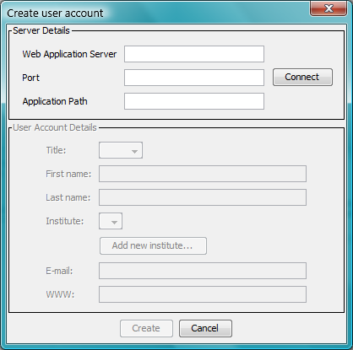

Figure : Create User Account dialog

* Enter the Web Application Server, Port and Application Path strings that have been supplied to you by your database administrator.
* Click on Connect . The remaining fields on the screen will become active. If ANDS Publishing is supported for your database, ANDS related fields will appear in the dialog box as shown below. See Chapter for more information about the ANDS service and its operation.

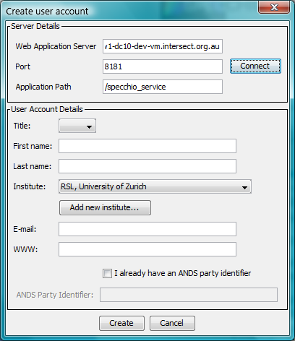

Figure : Create User Account dialog for ANDS users

* Select your Title and enter your First and Last Names. These will be used to identify the data which you upload to Specchio to other Specchio users.
* Select the name of your Institute from the dropdown list. If the name of your Institute is not present in the list, click on  Add new institute…  This will cause a small dialog box to appear. Enter your institute and department name and click on  Create . It is possible to create an empty institute name where both Institute and Department are blank. (Take care to enter these details correctly. There is no function to change or remove these names. If there is a need to change or remove a name, you will need to request your database administrator to do it for you.)
* Enter your email address and a URL which other Specchio users can use to contact you and access information about you.
* If your database supports ANDS Publishing and you already have an ANDS Party Identifier, set the checkbox and enter your ANDS Party Identifier in the following field. Take care when entering this field. You cannot change it once entered. If you do not have an ANDS Party Identifier, leave the checkbox unchecked and Specchio will create one for you.
* Click on  Create . The dialog box will close.

This process will generate the following information and store it in the database’s User list.

**User Name** A short name constructed from your own name which will be used to identify you when you log into the Specchio database.

**Password** A password that is required when you log into the Specchio database.

**ANDS Party Identifier** If your database supports ANDS Publishing, this string is generated. It identifies data which you Publish to ANDS. To view your ANDS Party Identifier, follow the procedure shown below for editing your User Account details.

A line is also added to the db-config.txt file on your computer. This line holds sufficient information for you to log into your database. See the next section for more information.

When you are logged on to Specchio, you can edit your User Account information.

* Select the Database and Edit user information menu items to display the following dialog box.

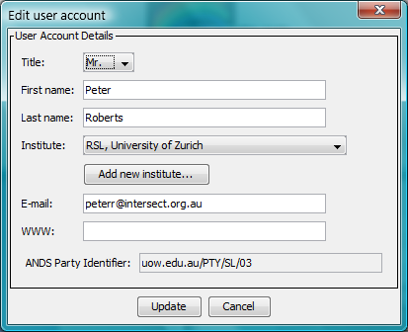  
%%% Confirm what details should be in this screen dump.

Figure : Edit User Account dialog

* Update the details as you require and click on  Update . All fields can be changed on this dialog box except the ANDS Party Identifier.

## Administrator Access

Certain Specchio functions, such as uploading Instrument definitions and Calibrations, require administrator permission. For normal Users, these operations on their respective sub-menus are greyed out.

When the Specchio database is created, it has an Administrator account defined. The User Name and Password for this account are not generally advertised. See your Specchio Administrator if you require access to these administration functions.

## Campaigns

Data uploaded to SPECCHIO are organised into Campaigns. Ideally, a new Campaign is created to hold data for every new sampling experiment.

On your computer, the spectral data files for a Campaign must be held by a sub-directory structure which organises the spectral data according to their function. (For more information see section .) This sub-directory structure will be replicated in the Specchio database when the Campaign data are uploaded. The sub-directory structure should not be renamed, moved, reorganised or deleted after uploading, so that additional data can subsequently be uploaded easily.

Typically, the operations carried out for each campaign are:

1. Creation of a new Campaign in Specchio and linking it to the sub-directory of spectra on your computer’s disk
2. Uploading of spectra data from your local disk to the Specchio database
3. Entering of metadata into the Specchio database for the uploaded spectra
4. Repeated data query, visualisation, processing and file output based on the uploaded data

New data can be added to ongoing Campaigns by first storing them in the already existing Campaign sub-directory data structure on your computer’s disk and then invoking the SPECCHIO loading operation for the entire Campaign again. Only new spectra discovered in the sub-directory hierarchy will be added to the database in this case. Existing data will not be duplicated.

## Research Groups and Accessing Specchio Data

When you upload data for a Campaign to Specchio, all Users of your Specchio database can access your Campaign. However, only you can modify or delete it unless you specifically allow others to have write access to it. This access is controlled by setting a Research Group of Users for each Campaign that you upload. Just as you can add other Users to the Campaign’s Research Group, so you can remove them too.

The membership of each Research Group is stored as metadata for the Campaign. See for more information about metadata and for instructions for updating it. Each Research Group applies only to one Campaign.

When you add another Specchio User to the Research Group for your Campaign, that User gets all the rights that you have for that Campaign. That is, they can modify the data, add to it or remove it. They can also change the membership of the Research Group.

Note It is not recommended to remove the original uploader of the Campaign from the list of Users in the access Research Group. This does not make sense, and may lead to unexpected results.

## Time Data

SPECCHIO expects times for Spectra acquisition to be in UTC (Coordinated Universal Time). For practical purposes UTC is considered equivalent to GMT. However, the term UTC is recommended for technical contexts [1].

The above implies that all computers capturing data for use in SPECCHIO have their time zone set to GMT and their system time adjusted to UTC. However, this is not usual, so the Spectrum acquisition date/time can be modified in the database using a function in the Metadata Editor if a time different from UTC was used.

## Data Links

%%% I can’t get data links to work. I always get a Java error and the progress bar sticks at 0%. You can close the progress bar box and retry, but I always get the same result no matter which spectra I highlight. 500 internal server error on POST. 2/5 Nick gets the same error, but it works for him on GER\_Example, where it fails for me. JIRA DC10-180.

%%% Are there still three varieties of data link? 2/5 Nick will check with Andy.

%%% Is it possible to view the data links in any way? I can’t find a way. How does a user tell that they’re set up correctly? 2/5 Nick will check with Andy by email.

Data links define relationships between data sets or single spectra. That is, data links are 1:1 relationships between either two hierarchies or two spectra. There are three types of data links.

Photometer data %%% explain what these types actually mean.

Spectralon data %%%

Radiance data %%%

In some cases data links are set up automatically during campaign data loading. For example, GER signature files include the spectra of both target and white reference.

For more information on data links see 6.2.1 (%%% No info in ASD section, should it be reference to following section GER?) and 6.4.2.7.2.

SPECCHIO refers to data link information in some of its operations, for example the automatic calculation of reflectance from target and reference radiances.

## Sensors and Instruments

SPECCHIO defines Sensors and Instruments, which are modelled as two different entities in the database.

%%% Maybe a diagram describing sensors, instruments and calibrations and their linkages could be helpful here. A sort of Booch diagram.

Sensor A physical setup of sensors, i.e. number of channels, average wavelength and FWHM per channel, sensor type number (usually a code given by the manufacturer, e.g. 4 for ASD FSFR sensor). Sensors are defined only once in the database. %%% Would this also be a Sensor type”, as referred below, or a “Instrument model”?

Instrument Existing instances of a certain sensor type. There can be several different instruments that are all of one sensor type. Instruments also have a defined owner and a history of calibrations.

Consider the example of a GER 3700 instrument: this instrument is an instance of a GER 3700 sensor. The sensor defines the average wavelength per channel. As long as no calibration for the instrument has been entered into the database the channels defined in the sensor will be used for plotting and exporting spectral data. When calibrations are entered for instruments they override the sensor specifications. For further information please refer to [2] %%% Check this reference. It could be one of three. Even better, remove the need for it, because these references are all references to info which should be in this document.

Note Instruments that change the number of stored spectral bands based on user configurations (such as is possible with the new SVC HR-1024) are not yet supported.

## Metadata

Specchio allows Users to store metadata about the data they have uploaded into Specchio Campaigns. It is stored at two levels: Campaign Related Metadata and Spectrum Related Metadata.

For more information on the metadata parameters supported by SPECCHIO please refer to Hüni et al.(2007). [2] %%% Check this reference. It could be one of three. Even better, remove the need for it, because these references are all references to info which should be in this document %%% Can I see these three references? Ask Andy.

### Campaign Related Metadata

The following metadata can be set for each Campaign.

|  |  |
| --- | --- |
| Campaign name | The name under which the Campaign is stored in the Specchio database |
| Description | A free format description of the Campaign |
| Investigator | The person in charge of this Campaign (i.e. the User defining and loading the campaign). This field is filled automatically and cannot be changed. |
| Path | The file system path pointing to the main directory from which this Campaign was uploaded.  This value should be changed if the Campaign folder was shifted on your computer after the uploading of the Campaign. It will assist if further data is uploaded for this Campaign. |
| Research Group Members | A list of Users of this Specchio database who have permission to modify this Campaign. |

### Spectrum Related Metadata

When Spectra are uploaded to a Campaign, the Specchio upload process identifies metadata found in the Spectrum files and copies it into Specchio Spectrum Metadata fields for each Spectrum it uploads. Once uploaded, this Metadata can be viewed, edited or added to, as described later in this User Guide.

Similar Metadata are grouped into sections to facilitate management.

This section lists the Metadata fields which can be stored for each individual Spectrum. Users cannot enter Metadata except into these already defined fields. If new Metadata fields are required, they can generally be defined easily. Contact your System Administrator with a detailed description of the Metadata field you need added and a specification for the data that it can contain.

%%%% There is a help function which explains all metadata which explains it all. Andy will send Excel spreadsheet which explains it all in good detail (received 1/5 – review it). This does mostly not detail what it’s for nor units, but it does give the expected format (e.g. fl pt vs. string vs. int)

**Campaign Details**

These metadata fields are not intended for general use. Some formats for spectrum files contain Campaign-related information, particularly HDF formatted files. When spectrum files of these formats are loaded, the Campaign-related metadata that they contain is loaded into these fields. This allows you to review it and, if necessary, manually transfer it to the Campaign-related metadata fields described in section .

It is not recommended to otherwise enter Campaign metadata into these Spectrum-related metadata fields. Instead, use the Campaign Metadata fields described in section .

|  |  |
| --- | --- |
| Agency Code | [Alpha string] Copied from the Agency Code field if it is set in the related spectrum file (particularly HDF files) when it is loaded. |
| Campaign Name | [Alpha string] Copied from the Campaign Name field if it is set in the related spectrum file (particularly HDF files) when it is loaded. |
| Project ID | [Alpha string] Copied from the Project ID field if it is set in the related spectrum file (particularly HDF files) when it is loaded. |

**Data Portal**

These metadata relate to the Publishing of the Spectrum on the Australian National Data S%%% system. %%% Why is it here and not in the Campaign level, as Campaigns are published, not Spectra, and what happens if you change it for just one Spectrum. Explain this here.

%%%% Nick says these fields should be set before publication for each spectrum.

|  |  |
| --- | --- |
| ANDS Collection Key | The ANDS Collection Key of the most recent Publication which included this Spectrum.  %%% Possible to change it or add them, but just don’t.  %%% It should list all publications, but this needs testing. Log in JIRA if it doesn’t. |
| Data Usage Policy | %%%% Owner indicates who or what should be cited. It predates ANDS Publication. It fills in RIF-CS “Rights Statement” field. |
| FOR Code | %%% Refer to the same website as DC20 did. |

**Environmental Conditions**

These metadata describe the environmental conditions at the time the Spectrum measurements were taken.

|  |  |
| --- | --- |
| Air Pressure | [hPa] |
| Ambient Temperature | [degrees Celsius] |
| Cloud Cover | [int 0 ~ 8] Description of the cloudiness of the sky by octas:  “For the total cloud amount, codes 0 to 8 show the fraction, in octas, of the celestial dome covered by all clouds. An octa is one eighth of the celestial dome, so we estimate how many eighths of the celestial dome are covered up by clouds.” (Source: University of Washington (undated))  **Code Meaning**  0 Clear sky  1 1 octa or less, but not clear sky  2 - 6 2 - 6 octas  7 7 octas or more, but not total cloud cover  8 Total cloud cover  %%%% Octas are gone and a percentage cloud cover replaces it. Check in program itself. |
| Relative Humidity | [%] |
| Weather Conditions |  |
| Wind Direction | direction from where the wind originates in 45 degree steps: N, NE, E, SE, S, SW, W, NW  %%% Bearing? You can enter any fl pt number. |
| Wind Speed | calm, breezy, windy, stormy  %%% But the app requires a fl pt number! Units? Way of estimating? |

**General**

This metadata group collects together information about the Spectrum’s file.

|  |  |
| --- | --- |
| Acquisition Time | Capture date and time in 24h format (UTC). This time is set from %%%. If this is not set to UTC, it is necessary to adjust the time to UTC using the Special functions/Correct local time to UTC function described in section %%%.  %%% Is this ever correct at upload? Is it always set from the system time – client or server’s? |
| File Comments | [Alpha string] %%% Purpose?  Specchio sets any comments entered when capturing the spectrum (e.g. possible with ASD’s R3 capturing software) into this field on spectrum upload. |
| File Format | The format of the file from which this Spectrum was uploaded. It is selected from a dropdown list of supported file formats. (All Spectra are stored internally in the database in Specchio’s internal Spectrum format.)  While this value can be changed, it is not advised. |
| File Name | The name of the file from which this Spectrum was uploaded.  Although this value can be changed, it is not advised. Changing it may result in duplicate spectra when a subsequent update load is performed for this Campaign. |
| File Version | [alpha string] |
| Loading Time | Date in 24h format (system time) on which the spectrum was uploaded into the Specchio database. (Note that the Special functions/Correct local time to UTC function does not operate on this time.) |
| Measurement Unit | Name of the spectral measurement unit (reflectance, radiance, absorbance, transmittance, DN, wavelength, Mueller10, Mueller20) |
| Spectrum Number | [+ve int] Some recording devices apply a number which is recorded in the Spectrum file for some file formats. If a Spectrum is loaded from such a file format, the number will be placed into this Metadata field. Otherwise, %%% what happens?  Note that this number is not the Spectrum ID and usually does not hold the same value as the Spectrum ID. The integer numbers which are displayed when Spectra are selected in the Query Builder or when a Spectrum is highlighted in the Hierarchy Viewer are Spectrum IDs. Spectrum Numbers are viewable only in the Metadata Edit window and selectable in the Query Builder.  Spectrum Numbers can be changed in the Metadata Editor. Spectrum IDs cannot be changed.  %%%% It should be alpha-numeric, so check the actual program. |

**Generic Target Properties**

|  |  |
| --- | --- |
| Sample Collection Date | [date and time] |
| Sample Number | [alpha string] |
| Site ID | [alpha string] |
| Target Description | [alpha string] |
| Target ID | [alpha string] |

**Illumination**

|  |  |
| --- | --- |
| Polarization | [alpha string] %%% What goes here? |
| Polarization Angle | [fl pt number] %%% Angle measured from where? Degrees? |

**Instrument**

%%%% Instrument is defined by a sensor definition. Calibration can also be done. Instrument settings at time of measurement can be added to spectrum metadata.

* Name: name of an instrument (this is the name given to the instrument by its owner) %%% Still stored?
* Foreoptic: degrees %%% Still stored?

Instrument Settings:

* Instrument settings, depending on the sensor. Automatically generated from the spectral input file.

|  |  |
| --- | --- |
| Instrument | Instrument type selected from a predefined list of instrument types. (%%% models?) %%% Name chosen from list of known instruments. Use Instrument function metadata editor.  If you load a spectrum with a reference to an unknown instrument, it will place it in the instrument table with dummy info. Then Instrument metadata can be used to fill in data manually. |
| Sensor | Sensor type selected from a predefined list of types. (%%% models?) See Load Sensor definition. Special format text file (CSV) which defines sensors. Each instrument has a sensor. |
| Calibration Number | [+ve int] %%% Calibration of a sensor. Sometimes it’s in the data files. It’s usually a code which is incremented each time the sensor is sent away for recalibration. Check if it’s really a +ve integer. The timestamp of the acquisition on the spectrum which should be used to refer back to the history of the instrument to determine the calibration is the only sure-fire way. |
| Extended Instrument Name | [alpha string] %%% |
| Instrument Serial Number | [alpha string] %%% |

**Instrument Settings**

Instrument settings, depending on the sensor. Automatically generated from the spectral input file.

|  |  |
| --- | --- |
| Automatic Dark Current Correction |  |
| Capturing Software Name |  |
| Capturing Software Version |  |
| Gain SWIR1 |  |
| Gain SWIR2 |  |
| Instrument Channel |  |
| Integration Time | [ms] |
| Number of Internal Scans |  |
| Offset SWIR1 |  |
| Offset SWIR2 |  |
| Time since last DC |  |
| UniSpec Spectral Resampling |  |

**Instrumentation**

%%% How does the objective of this group differ from Instrument and Instrument Settings? This is any further manually recorded information related to the measurements made. HDF Files – are a special file format for Finnish Geodetic Institute which have a lot of this info in them.

|  |  |
| --- | --- |
| Azimuth Sensor Type |  |
| Goniometer | Goniometer: FIGOS, LAGOS or FIGIFIGO – %%% Check whether these items are a predefined list or not. |
| Illumination Sources |  |
| Integrating Sphere |  |
| Light Source Parameters |  |
| Reference | %%% Is this the Reference Panel field? Andy says, There is a drop down list of reference panels defined in the Instrumentation Metadata editor.   * Name of the used reference panel * Button to bring up a new window showing information about the reference panel (see Figure 8)   %%% Figure 9 doesn’t seem to be in V3. |
| White Reference Target |  |

**Keywords**

Keywords can be used to search for particular spectra. %%% Why is it here and not at the Campaign level? %%%% You can click on the Campaign level and change the Keywords.

|  |  |
| --- | --- |
| Keyword |  |

**Location**

This group collects information about the capturing location.

|  |  |
| --- | --- |
| Altitude | [m] metres above sea level |
| Latitude | [degrees] Northern hemisphere coordinates are positive, southern negative. Coordinates are entered as degrees and fractions of degrees. |
| Longitude | [degrees] West of Greenwich: positive. East of Greenwich: negative |
| Location Name | %%% Is this the same as “Location” in the old system?  Free text |
| State | [alpha string] %%% Presumably SA, NSW etc. Why not a drop down? Is it international? Could be a configured list. |

**Names**

This group collects the possible names for the species or objects in the spectrum sample.

|  |  |
| --- | --- |
| Common | [alpha string] %%% |
| ENVI Header | [alpha string] When ENVI Files are loaded (see ), the content of the Spectrum Names tag is copied here, if it is set. |
| Latin | [alpha string] %%% |

**Optics**

|  |  |
| --- | --- |
| FOV | [int degrees] Field of View angle |
| Optics Name | [alpha string] %%% |

**PDFs**

|  |  |
| --- | --- |
| Experimental Design | [Uploaded PDF file] %%% I can upload, but I can’t View. And it appears that change, remove, delete are not supported. |
| Field Protocol | [Uploaded PDF file] %%% |

**Personell**

|  |  |
| --- | --- |
| Investigator | %%% How does this relate to the Campaign investigator? It comes from the HDF files. Generally, preferably, enter the investigator as a member of the research group. |

**Pictures**

A list of pictures plus captions. Currently only the JPEG format is supported. %%% Seems to have changed in structure.

%%%% There are other formats supported now. Nick will give me a list of them.

%%%% Captions are no longer supported.

Note Pictures should be reduced in size before loading to the database for speed reasons. Appropriate sizes are around 400 to 500 pixels width or height.

|  |  |
| --- | --- |
| Sampling Environment | %%% I get an error every time I try to upload any one of these four. |
| Sampling Setup |  |
| Sky |  |
| Target |  |

**Processing**

|  |  |
| --- | --- |
| Data Ingestion Notes |  |
| DC Flag |  |
| Garbage Flag |  |
| Processing Algorithm |  |
| Processing Level |  |
| Processing Module |  |
| Source File |  |
| Time Shift | This records the first time shift processing event that was applied to the spectrum using the Special functions/Correct local time to UTC operation. See %%% for more information on changing the times. |

**Sampling Geometry**

Numbers in this group can all be entered as floating point numbers.

|  |  |
| --- | --- |
| Beam Geometry | SPECCHIO supports the nine fundamental beam geometry types describing the incoming and reflected beams. They are selected from a predefined list of geometries.  Bidirectional (CASE1)  Directional-conical (CASE 2)  Directional-hemispherical (CASE 3)  Conical-directional (CASE 4)  Biconical (CASE 5)  Conical-hemispherical (CASE 6)  Hemispherical-directional (CASE 7)  Hemispherical-conical (CASE 8)  Bihemispherical (CASE 9)  For further information about the beam geometry types, please refer to (Schaepman-Strub, Schaepman et al. 2006) and Figure 5 below. |
| Illumination Azimuth | absolute angle in degrees |
| Illumination Distance | distance from source to target |
| Illumination Zenith | angle in degrees (where 0 degrees is equal to nadir) |
| Sensor Azimuth | angle in degrees measured relative to the principal plane. I.e. 0 degrees = the principal plane opposite of illumination source) |
| Sensor Distance | distance of sensor to target in metres |
| Sensor Zenith | angle in degrees (where 0 degrees is equal to nadir) |



Figure : The nine beam geometry cases (Schaepman-Strub, Schaepman et al. 2006)

**Scientific References**

|  |  |
| --- | --- |
| Citation |  |
| Publication |  |

**Soil Parameters**

|  |  |
| --- | --- |
| Too Many To List! | %%% Look for a pattern to simplify listing. |

**Vegetation Biophysical Variables**

|  |  |
| --- | --- |
| % Crown Cover |  |
| Approx. Crown Diameter |  |
| Chlorophyll Content |  |
| Crown Class (FPMRIS) |  |
| DBH |  |
| Dry Weight |  |
| Height |  |
| Leaf Area |  |
| Specific Leaf Area |  |
| Water Content |  |
| Wet Weight |  |

Spectrum Data: %%% There seem to be some leftovers here. Are they implemented in this version of the app?

* Is reference: an option that can define this spectrum as being a reference spectrum. Only specchio\_admin can set this field. %%% I think this is no longer true. I asked Andy, but I need to get my head around Links before I can understand this. Check the app.

General Data:

* Sampling environment: Defines the general type of environment where the sampling took place: field, laboratory, hdrf to brf, or model. ‘model’ stands for simulated data using a computational model of some sort. %%% Andy says it’s now under general? I can’t find it there. There is a Sampling Environment Picture, but that seems to be different. Check again with Andy.

Target Type: %%% Can’t find this one – Andy thinks it’s still supported. He’ll let me know.

* Defines the target type and the abundance of this target type in the sampled object (cf. also 0). Further target types can be defined by the administrator. Use the Add, Edit and Remove buttons next to the list to change to contents of the list.

Associated Measurements: %%% Can’t find this one – Andy says, these are things like soil attributes. They are part generic metadata. Check with in the Soil Type lists. This can then probably be deleted.

* Add any number of measurements (geo-physical parameters) associated with the current spectral measurement. Ask your administrator if physical units are missing.

Target Types

%%% I can’t find Target Type in any of the metadata groups or in the app anywhere. Should it be removed from the document? Check the app again, and refer also to Instrumentation/Reference, which may be this one.

Target types are predefined in the database and can only be edited by the SPECCHIO administrator. Target types should always be chosen with the goal to help the search and selection of spectra, for example image classification tasks. The target types should therefore not be too detailed.

It is foreseen that target types can be grouped into categories. This might be implemented in future when the number of target types becomes a handling problem for the user.

### Other metadata stuff

%%% This needs review with Andy or Nick before removing it. It may be that some of it still applies, but it’s in a different place in the app.

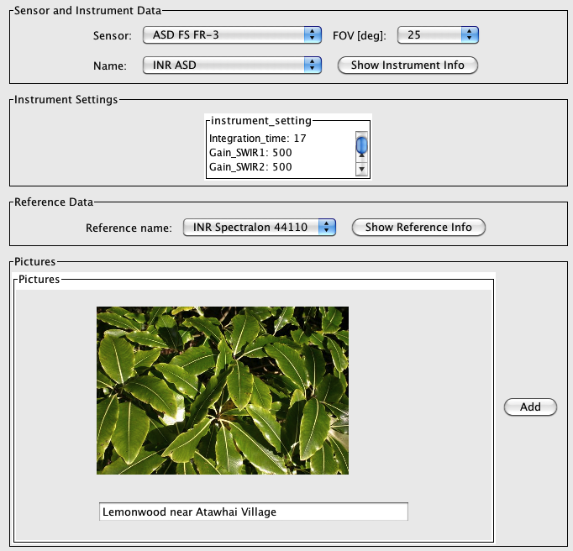

Figure : : Spectrum data tab (part 4)

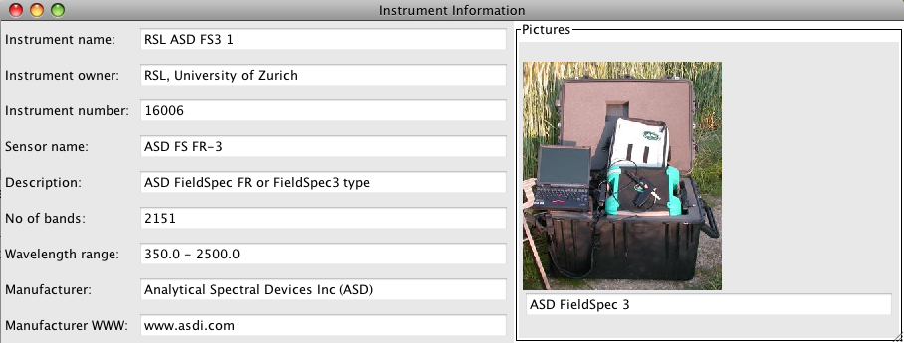

Figure : Instrument information window

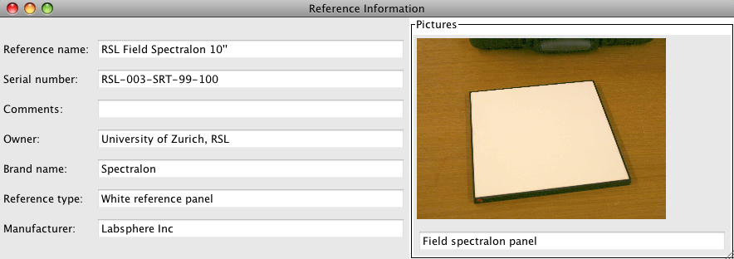

Figure : Reference panel information window

## Spaces, Space Factory and Data Processing using the Space Network

%%% Talk to Nick about whether it should Alpha Release or something else. Andy suggests (on 30/4) it should maybe be Beta or no comment. He will look at it.

SPECCHIO offers interactive, configurable data processing. The concept is based on the feature spaces [3] and complex process flows can be realised by building networks consisting of spaces and processing modules. For detailed information please refer to: [4] %%% Check this reference – there are multiple options.

Spaces are used throughout the system for processing, visualisation and file output. In all these cases, vector data must be related to spectral dimensions and this information is held by the space. Moreover, a space can hold only spectra that are of the same dimension.

The Space Factory is a conceptual, central component of the SPECCHIO system. It creates new spaces based on given inputs and contains the logic to form ‘non-mixed’ spaces.

Assume the use case of displaying spectral plots of a number of spectra. In a first step, the user will select the spectra to be plotted by effecting a subspace projection [5]%%% Check this reference – there are multiple options. Internally, this will yield a number of record IDs that are matching the user’s selection. These IDs are now handed to the Space Factory. Internally, spaces are created for all existing combinations of the respective sensors, instruments, calibrations and measurement units associated with the spectra (see Figure 9).

:::::Papers and Presentations:2009:EARSEL 2009:Space Factory Graph.pptx.pdf

Figure : Building spaces based on user defined subspace projections

The Space Factory returns a list of the created spaces. Each space can now in turn be used as an input argument of a plotting class instance. Utilizing the Space Factory ensures that all spectra contained by a space have a common wavelength per band and the same measurement unit, i.e. the following processing modules do not need to carry out uniformity checks but can apply their algorithms directly, e.g. plotting of spectral vectors against the common wavelengths of the space.

Interactive, flexible and configurable data processing is based on the concept of the Space Network. Such networks consist of processing modules and data sinks/sources, connected by directed edges.



Figure : Transformation into a new space by a processing module

Processing modules are effecting a transformation on a space, i.e. the spectral data vectors of the input space are transformed to an output space. The algorithm of the processing module defines the dimensionality of the resulting space. This is illustrated in Figure 10 with an input space of dimensionality N being transformed into another discrete space of dimensionality M. Although processing modules tend to have singular input/output in most cases, they may have multiple inputs and generate multiple outputs.

## Operational Dataflow

%%% This should be much earlier, and perhaps expanded and renamed to give a better overview and define a few words.

A typical dataflow is illustrated in Figure 11. A spectroradiometer is used to capture the radiance of field objects. Optionally a GPS connected to the field laptop (where supported by the capturing software) records the spatial position of the field object. This is a recommended setup as the spatial position can later be automatically loaded into the database. Spectral and metadata are automatically saved on the field laptop.

These files are transferred to a laboratory computer where they are read by the SPECCHIO application and stored in the relevant tables in the spectral database.



Figure : Dataflow and involved hardware

## Supported Input and Output File Formats

SPECCHIO provides loading support for the following file formats.

* ASD binary file as produced by the ASD FieldSpecPro/FS3 spectroradiometers
* ENVI Spectral library files (SLB and SLI)
* GER signature files as produced by the GER 3700 (Files produced by other GER instruments remain subject to testing)
* TXT space formatted text files
* MFR Photometer OUT files
* Apogee files (restricted to one tested file format only)
* SVC HR-1024 files (using PDA acquisition)
* Ocean Optics Spectra Suite
* HDF5 files and xml files containing measurement data from FGI (Finish Geodetic Institute) goniometer measurements
* New ASD file format (Indico Version 7)
* Proprietary sensor definition file. Sensor definition files are an efficient way of defining new sensors in the database.
* XML type file format for campaign imports for data transfer between SPECCHIO databases

Output can be written in three data formats. %%% What is written into these output files?

* CSV (Comma Separated Values) for subsequent import into various 3rd party applications like spreadsheets or statistic packages
* ENVI Spectral Library (SLB)
* XML type file format for campaign exports (for data transfer between SPECCHIO databases)

# Design of Sampling Experiments and Data Structuring

This section contains a description of a setup of a possible spectral sampling campaign. Users designing their own sampling campaigns and planning to load them into SPECCHIO can find some basic ideas on campaign planning and data structuring hereafter.

## Overview

The data collected during sampling campaigns must be organised in a structured way in order to allow the automated import into the spectral database. Section 4.2 explains the background of the structure used and section 4.3 gives a practical example of a directory and file structure that should be adopted for data collection.

Preferably sampling experiments should be designed to include some form of data structuring from the beginning. Alternatively, existing data can be arranged to meet the requirements.

## Hierarchical Structure

The concept of hierarchical data structure has been adapted from SpectraProc (Hueni 2006).

SpectraProc was built on a fixed hierarchy of three levels. The following example is based on the sampling design used for SpectraProc campaigns.

A hierarchical data structure that reflects the real world and the setup of sampling campaigns for vegetation is used. This structure is derived from the following conditions:

1. Reflectances of several different species are captured

In order to describe the in-species variation, several specimens of a species are sampled

The variability of the specimens is described by several measurements per specimen

The spatial extent where a specimen is sampled is termed a sample site, thus a species contains a number of sample sites. The sites are numbered in the order of sampling. At each site, several readings are taken to capture the variation exhibited by the specimen in question. A site therefore contains a number of spectra. This leads to a hierarchical directory structure (Figure 12).



Figure 12: Hierarchical directory structure

Although the term species is used it essentially represents the different classes found in a study. These classes can either be assigned due to already existing classification systems for e.g. plants or minerals. In other cases a hypothesis might exist that a number of objects can be separated into classes. If so the setup of the experiment should mirror this hypothesis. If no such assumption exists all objects can be put into the same class (i.e. species) and the identification of classes could then be carried out by e.g. cluster analysis.

SPECCHIO builds up on the above concept of hierarchies. However there is no restriction on the number of levels used. Thus any level number (0:N) can be used.

## Directory Structure and Spectral Files

This section lists examples of data structures employed to hold the files generated by spectroradiometers. Note that SPECCHIO enforces no particular structure. The provided examples are mere suggestions based on experience and you may decide to choose a different approach.

### Structure to store Reflectance Spectra of several Species and Sampling Sites

A hierarchical structure as introduced in 4.2 is used to build the directory structure that holds the spectral files. Ideally, this directory structure is setup when designing the experiment.

Figure 13 shows an example of a directory structure containing ASD spectral files. The main directory ‘Vegetation\_example’ holds all species directories of the study. This main directory is the folder that needs to be specified when creating a campaign in the database (cf. 5.4). The species directories contain the site directories.

The site directories contain all spectral files collected at these sites. The spectral files are auto-numbered by the ASD capturing software.



Figure 13: Example of a directory structures holding spectral files

Campaigns can contain spectra measured with different instruments and sensors, i.e. instruments of different sensor types and instruments with different calibration dates. The only restriction that is imposed is that a hierarchy (i.e. a folder) can contain only one file type.

One exception to this restriction can be found for the import of FGI-HDF files. There it is possible to have an .h5-file as well as a .xml-file in one folder. But it is important not to mix files from different data structure versions in one folder.

### Structure to store Reference and Target Spectra

If a spectroradiometer is configured to acquire radiances, the irradiance will commonly be characterised indirectly by measuring the radiance reflected by a reference panel. This may be preferable to the direct acquisition of reflectance data as information about the irradiance can be retrieved from the dataset.

The structure must therefore hold target and reference radiance spectra.

A possible structure is shown in Figure 14:



Figure 14: A possible structure for the storage of target and reference radiance spectra

# SPECCHIO Basic Operation

SPECCHIO has been setup to comply as much as possible with the look and feel of the operating system on which it is running.

The screenshots provided in the following sections have been taken on Windows XP and MacOS X. Depending on your system, the windows and widgets may look different. %%% Consider a change to this comment after screenshots are redone.

## Unix Operation

The functionality of the GUI is generally consistent across all tested operating systems. However, there is a difference in the selection of directory pathnames under UNIX. As a filename is required in the Open dialog, enter a dot ‘.’ in the filename box (Figure 15). Alternatively, on some UNIX machines just click the folder but do not double click, in this fashion the folder will be selected and no ‘.’ has to be inserted in the filename box.



Figure 15: Specifying a pathname under UNIX using the dot ‘.’ as entry in the filename box

Depending on the UNIX windowing system, some of the dialogs are not properly displayed unless they are maximized.

## Main Window

Specchio’s Main Window opens when the application is started. It is used to launch all of Specchio’s functions.

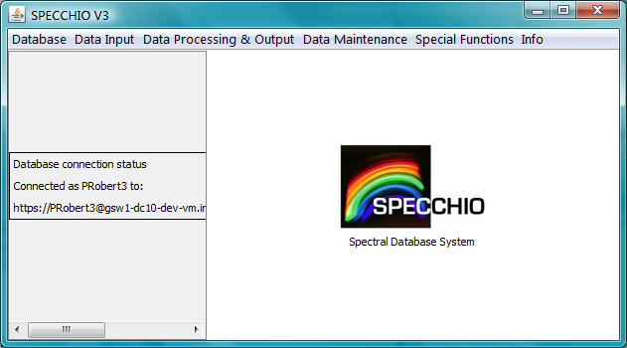 :::Plots and Graphs and Screenshots:Main Window.ppt.pdf

Figure 16: Main window

%%% After making final screenshots, copy annotations to it.

Main menu Select the Specchio functions you wish to run from here.

Progress Report Panel Displays the database connection information and information about the progress of many of Specchio’s processes (e.g. file loading).

Database Connection Information Is displayed in the Progress Report Panel and shows the User Name you are logged in as, and the database you are logged in to.

The panel on the right side of this window is not used in this version of Specchio.

## Logging In and Connecting to a Database

Because the user account details are kept in the database, connecting to the Specchio database and logging in are performed together.

Preconfigured information for your database and the log in accounts you have created on your computer is stored in the db-config.txt file on your computer. See section for instructions on creating a User Account.

* Start the Specchio Application. (See the instructions specific to your computer in section %%% Currently 2.2, but may change so put in link later.)
* Select the Database and Connect to database menu items from Specchio’s Main Windows to display the following dialog box.

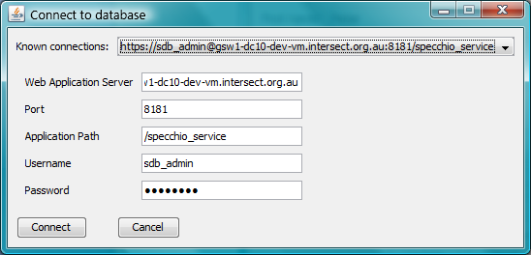

Figure : Connect to Database dialog

* From the Known connections dropdown list, select the connection with your User Name following the https:// characters. The User Name will be a contraction of your own First and Last Names.
* Inspect the values which are updated in the dialog box. It should not be necessary to change anything unless specifically requested by your database administrator.
* Click on  Connect . The dialog box will close and there will be short delay while the database is read. The details of your database and log in account will be displayed in the left hand panel of the Main Windows and the sub-menu items for Specchio functions will now be active.

You can repeat this process at any time and log in as a different User, or even log in again as the same User.

### SSH Connection

%%% I think this is no longer true, because direct DB access has been disabled. Remove if necessary.

SPECCHIO can connect to database servers using SSH tunnelling. The SSH authentication must be based on public-private keys or on a username/password combination.

Both access options can only be invoked by specifying the connection strings in the db\_config.txt file. SSH connection are invoked by selecting them from the known connections drop-down menu.

Format and example for public-private key connection:

server, ssh\_port, ssh\_username, id\_dsa file path, db\_server, db\_server port, schema, db username, db password

apex-cal-is.geo.uzh.ch, 22, XXXXX, ,/Users/andyhueni/.ssh/id\_dsa, 127.0.0.1, 3306, apex\_cal\_is, apex\_cal\_is\_user, XXXXXXX

Format and example for username/password connection:

server, ssh\_port, ssh\_username, ssh\_password, db\_server, db\_server port, schema, db username, db password

130.60.16.70, 22, joe, XXXXXXX, 127.0.0.1, 3306, apex\_cal\_is, apex\_cal\_is\_user, XXXXXX

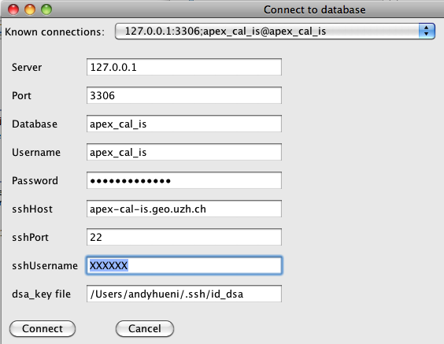

Figure : SSH connection fields using public-private keys

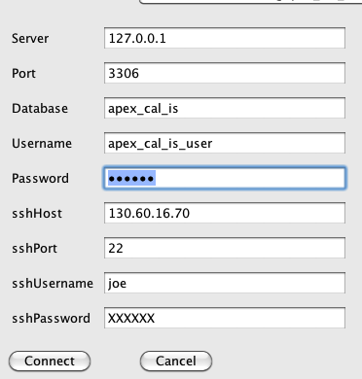

Figure : SSH connection fields using username/password combination

## Logging Out

There is no specific log out function for Specchio. Closing the Main Window will close your database session. If you restart Specchio, you will need to log in again.

If you select Database and Connect to database from the Specchio Main Window menus while you are logged in, Specchio will log you out before logging in again as the new User.

## Changing your User Details

After you have logged in and connected to your database, you can adjust your User Information.

* Select Database and Edit user information from the menu items from the main Specchio screen. The following dialog box will be displayed showing your User information.

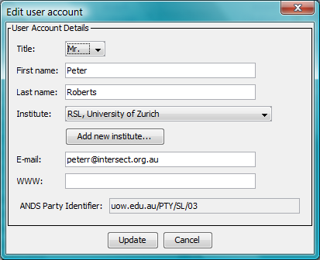

Figure : User Information update dialog

* Update the information as required. You cannot change the ANDS Party Identifier.
* Clink on Update to cause the changes to be written back into the database.

This process does not change your User Name or Password, so there is no requirement to modify anything in the db\_config.txt file.

# Loading Data into Specchio

## Creating a new Campaign

* Select Data Input and Create new campaign from the Main Window menus (**Error! Reference source not found.**). This brings up the new campaign dialog.

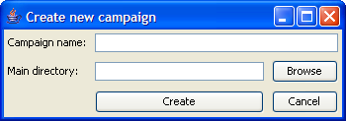

Figure : New campaign dialog

* Enter the name you have selected for this Campaign. The maximum length is 45 characters.
* To set the Main directory, select the Browse button to display a directory tree (Figure 22). The Main directory path is a file system pathname pointing to the directory that contains all hierarchies and spectra of this study. (When using a UNIX system you may have to enter a dot as filename – see .)

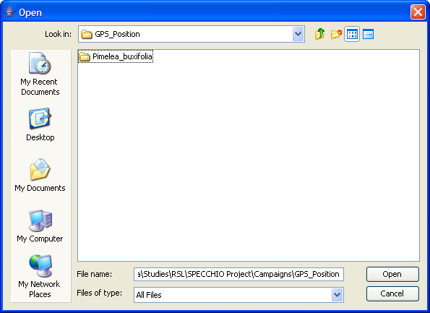

Figure : Directory selection dialog

* Click  Create  to create the new, empty campaign on the database. A message box will appear once the campaign has been successfully created.

Note There is no check if a campaign of the same name already exists. It is technically feasible to have two campaigns named the same. However, it is suggested to check on existing campaigns to avoid multiple campaigns with identical names.

No automatic loading of spectral files is initiated when a new campaign is created. To load data into a new campaign use the function ‘load campaign data’.

%%% Create and Load button isn’t documented.

%%% DC10-159 describes having multiple data upload paths for multiple computers. This changes the lay of the land a bit in this area. I new section needed here somewhere, and the key architecture diagram may need to be revisited.

## Loading Campaign Spectrum Data

Loading of Campaign Spectrum data occurs as a single operation. On your local disk drive, prepare a sub-directory structure which reflects the hierarchy you require for your data in Specchio and put your Spectrum data files into this sub-directory structure. It is OK to place spectrum files in intermediate sub-directories.

The sub-directory tree must contain only spectrum files, and each sub-directory within the tree must contain only one type of file format.

When you start the Spectrum load process, Specchio will process all sub-directories and files within this sub-directory tree and create a matching structure in your Campaign. For each sub-directory, it will open a file and check its format. It will then read all files in the sub-directory using the reading functions for that file format. If any file cannot be read, it will stop processing and advise you of the file which failed. Correct that file (either by removing it if it is not a spectrum file, or finding an uncorrupted version of the file). Then restart the upload process. Those spectra which have already been successfully uploaded will not be processed a second time.

%%% Clarify the following...

Note that if different file types (e.g. ASD binary files and GER signature files) are occurring in the same campaign, hierarchies must contain only one file type. This restriction is due to two reasons: (a) the file loading process is instantiating one concrete file loader class and applies it to all files in a directory and (b) it is against common sense to put files from different instruments/sensors into one directory. Consider a case where one species is being sampled with ASD and GER. A logical folder setup would be: a species folder with two subfolders for ASD and GER. These subfolders then contain the spectral files.

* Select Data Input and Load campaign data from the Specchio Main Window.

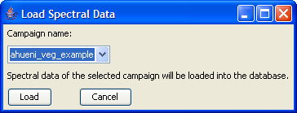

Figure : Load Spectral Data dialog

* From the list of Campaign names in the dropdown box, select the name of the campaign into which you want to load data.
* Click the Load button. The loading progress is shown in the Main Window. A message box will appear once all data has been loaded to the system.

If a campaign is ongoing over a longer period of time, new data can be added by first loading the new files and hierarchies into the existing file structure on your computer’s disc and then running the loading process again. Each spectral data loading process checks if hierarchies and spectra already exist in the database. Only new hierarchies and spectra will be loaded.

%%% Clearly the system identifies the input format being read. How robust is this process? Does the user need to take any precautions? For example, if the catch all TXT file uses an inappropriate heading name in the first column, can it be misrecognised as something else? Are file extensions used to help recognise the file type, or can you use any file extension you like? Clearly it sniffs one file from the directory to find out its type, loads that type’s loading class and then cycles through the directory files. It would appear then that you cannot have any other files at all in the directory – no images, no readmes, no other stuff at all, or it would crash the reading class. Even worse, it could be the one that gets sniffed, and that would stuff everything up for the whole directory. What’s more, you can’t have your images anywhere in your sub-tree or they’ll get found and the loading process will trip over them and stop. You can’t even put them in afterwards if there’s any chance you might have more data for this campaign to load later.

If a directory contains unknown file types, an according warning message is shown:

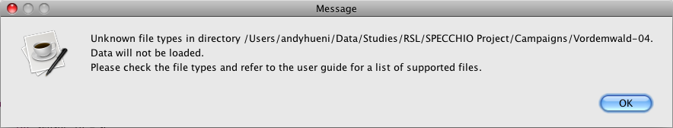

Make sure that the files in the indicated directory are supported by SPECCHIO.

%%% What should you do if you get this message? Delete teh Campaign hierarchy and start again? Correct and retry without cleanup? Does it tell you which was the offending file, so you can correct the problem? In the current app, does it tell you the directory? Check when server comes up again?

The following sections list all of the supported Spectrum file types.

### ASD Files

SPECCHIO has been tested with ASD FS3, ASD FS PRO and ASD FSVNIR binary files.

Since SPECCHIO version 2.2.0, the new ASD file format (Indico Version 7) is supported.

### GER Signature Files

These files hold two spectral measurements at once: the target and the white reference Spectra. When loading GER files two hierarchies named targets and references are created. The target and the reference Spectra filenames are duplicated in each hierarchy (e.g. Figure 24). A data link of the type Spectralon is created linking the target to the reference Spectrum.

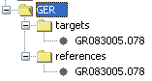

Figure 24: Automatically created hierarchies for GER files

### MFR OUT Files

These files contain the capture time, the sun zenith angle and the spectral data for total, diffuse and direct irradiance. The sun angle and the direct irradiance data are discarded and only the total and diffuse spectra are stored.

When loading these files two hierarchies named total and diffuse are created. The filenames assigned to the spectra are generated using the capture date and time. The same filenames will appear in the total and diffuse hierarchies (e.g. Figure 25).

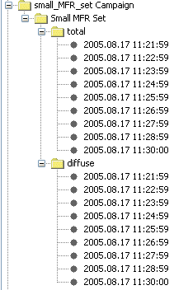

Figure 25: Automatically created total and diffuse hierarchies for MFR data

%%% Why are all the times in the above list :59 seconds, except for the last? It looks like a bug somewhere. It should be either corrected or commented on.

### SVC HR-1024 Files

SPECCHIO supports SVC HR-1024 files provided that they were captured using a PDA. Files acquired with a laptop are different in file format and are not recognised by the current file loading routine.

The HR-1024 stores radiances of reflectance panel, target and the computed target reflectance. During the data loading, SPECCHIO generates a hierarchical structure to store these files (see Figure 26), setting up data links that connect the reflectance to the target radiance (Radiance data link) and connecting the target radiance to the reference radiance (Spectralon data link). If the instrument was set to acquire radiances only (i.e. no white reference taken), then no special structure will be created.

Note It is highly recommended to enter the instrument into the database and load a wavelengths calibration. The wavelengths between instruments differ quite a lot and the blueprint sensor definition in SPECCHIO is only a poor representation of the real wavelengths.

%%% This diagram doesn’t match in style.

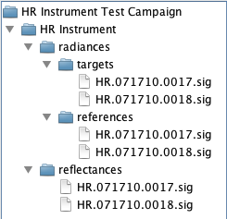

Figure 26: Automatically generated hierarchy for HR-1024 files

Examples of two valid files are given below:

/\*\*\* Spectra Vista HR-1024 \*\*\*/

name= \My Documents\HR1024\_Data\HR.071710.0017.sig

instrument= HR: 0761008

integration= 2, 22, 20, 12, 50, 30

scan time=1, 1

optic= LENS14, LENS14

temp= 31.29, 0.41, -5.71, 31.53, 0.41, -5.77

battery= 7.7, 7.7

error= 0, 0

units= Radiance, Radiance

time= 7/18/10 9:47:09 AM, 7/18/10 9:47:31 AM

longitude= 11121.2335,W, 11121.2324,W

latitude= 5330.5955,N, 5330.5964,N

gpstime= 154336.000, 154356.000

comm=

memory slot= 0, 0

factors=

data=

344.2 56023.55 4381.86 7.82

345.8 54418.00 4186.00 7.69

347.3 56037.65 4365.57 7.79

348.9 59474.63 4568.75 7.68

…

/\*\*\* Spectra Vista SIG Data \*\*\*/

name= \My Documents\HR1024\_Data\HR.080910.0010.sig

instrument= HR: 0971030

integration= 20, 19.2, 30, 200, 60, 30

scan time= 3, 3

scan settings= AD, AI, AD, AI

external data set1= 8224, 8224, 8224, 8224, 8224, 8224, 8224, 8224, 8224, 8224, 8224, 8224, 8224, 8224, 8224, 8224

external data set2= 8224, 8224, 8224, 8224, 8224, 8224, 8224, 8224, 8224, 8224, 8224, 8224, 8224, 8224, 8224, 8224

external data dark= 0,0,0,0,0,0,0,0

external data mask= 0

optic= LENS 4, LENS 4

temp= 36.21, 9.08, -5.30, 36.45, 9.08, -5.37

battery= 7.5, 7.4

error= 0, 0

units= Radiance, Radiance

time= 8/9/10 10:49:47 AM, 8/9/10 10:52:36 AM

longitude= 01116.9879,E, 01116.9933,E

latitude= 4806.4988,N, 4806.5075,N

gpstime= 084748.000, 085034.000

comm=

memory slot= 0, 0

factors=

data=

350.6 127369.73 4658.17 3.66

352.1 130962.30 4815.39 3.68

353.7 132239.65 4916.35 3.72

355.3 128726.40 4836.48 3.76

356.8 124030.10 4677.99 3.77

358.4 123421.08 4677.13 3.79

359.9 130810.10 4966.42 3.80

…

### Apogee Files

Apogee files are supported but not extensively tested as yet. %%% Is this still true? If they’re not tested, why are they released? If they don’t get tested, perhaps they should not be mentioned in the doc.

The file format currently recognised is shown below:

" File: cachimbalito2\p5\_2.TRM

" TRANS-> Wave:733.53nm Pix:1050 Val: 25.767 Time:23ms Avg:7 Sm:0 Sg:0 Tc:on Xt:1 Ch:1

400.00 1.102E+000

400.50 1.131E+000

401.00 1.205E+000

401.50 1.257E+000

402.00 1.260E+000

402.50 1.336E+000

403.00 1.341E+000

403.50 1.418E+000

404.00 1.451E+000

404.50 1.444E+000

405.00 1.488E+000

…

### ENVI Spectral Library Files

The import routine expects the spectral library files to have extensions of either .slb or .sli. A valid example is given hereafter:

my\_spectra.slb

my\_spectra.hdr

%%% How does .hdr make sense here? I was expecting the second file to be .sli.

These files can contain more than one spectrum. Specchio saves each spectrum separately. %%% Does it generate unique names?

If present, Spectra names are read from the header file and stored in the database as spectral name entry with a spectral name type = ENVI Hdr.

Note The sensor definition (i.e. central wavelengths) is not read from the ENVI header file.

Note Spectra loaded from ENVI SLB or ENVI SLI files are assigned a sensor based on the number of channels if existing; this approach may produce wrong sensor assignments. Use the Metadata Editor to set a sensor if needed.

### Ocean Optics SpectraSuite Data Files

The format of these files is as follows:

SpectraSuite Data File

++++++++++++++++++++++++++++++++++++

Date: Wed Sep 15 19:14:15 CEST 2010

User: telerilevamento

Dark Spectrum Present: No

Reference Spectrum Present: No

Number of Sampled Component Spectra: 1

Spectrometers: HR4C1076

Integration Time (usec): 1000000 (HR4C1076)

Spectra Averaged: 10 (HR4C1076)

Boxcar Smoothing: 0 (HR4C1076)

Correct for Electrical Dark: No (HR4C1076)

Strobe/Lamp Enabled: No (HR4C1076)

Correct for Detector Non-linearity: No (HR4C1076)

Correct for Stray Light: No (HR4C1076)

Number of Pixels in Processed Spectrum: 3648

>>>>>Begin Processed Spectral Data<<<<<

Wavelength(nm); radiance(W\*m-2\*sr-1\*nm-1)

717.00000;0.17904775

717.02000;0.17878146

717.04000;0.17849983

717.06000;0.17820124

…

%%% If this is a standard, why is it defined by example when other standards are not? Is it to allow the User to identify these files for some purpose?

The expected file extension is .csv, although the files are not comma separated as such.

The instrument number is taken to be the last four numbers of the spectrometer name, e.g. 1076 in the above example. The time format is expected to be as in the above example, i.e. it is probably depending on the settings of the controlling/post-processing computer.

### HDF5 Files containing FGI goniometer measurements

SPECCHIO is able to read HDF5 files that contain goniometer measurements carried out by the Finish Geodetic Institute (FGI). Specchio supports reading the newest data structure version with a coupled xml-file, containing all the metadata. But as this data structure version is still at an experimental stage (%%% Truly? Or just Specchio’s support of it?), the insert is not fully supported yet. %%% What isn’t supported, exactly?

As there are more than one spectra per file, each spectrum is saved separately. The name of each spectrum is constructed from the campaign name, the beam geometry (if HDRF or BRF), a data structure identifier and an auto numbered identifier (e.g. Snow7.HDRF.lib2.14).

### Excel files

%%%% XLS files are also supported. 30/4: see the XLS file in the vegetation example.

%%% Will it also load .CSV files, and can they be mixed with different Excel versions?

### TXT Space Formatted Text Files

%%% TXT loader is deprecated, except for calib info for reference panels. The company that supplies them supplies this format.

These files are formatted according to the following EBNF definition (Wirth 1977; ISO/IEC 1996).

%%% Is EBNF part of the normal knowledge of our audience?

%%% The grammar below doesn’t define leading or trailing whitespace, but the example that follows has both. It also doesn’t define the number formats or where <eol> goes in the grammar. I think this could be done more appropriately and more easily by example, as other file formats are done in this doc.

%%% It looks like the first column is a list of wavelengths, and subsequent columns are spectra values for those wavelengths. The first row is a list of corresponding spectra names, and the first value on the first line is probably ignored. Separators are white space, but are tabs OK?

%%% What happens if the format is not quite right? Test it.

txt\_file = header, data;

header = wsp, “wvl”, {wsp, spectrum\_name};

data = {d\_line};

d\_line = wsp, wavelength, {wsp, value};

wsp = {space};

An example follows:

wvl mean\_090499 mean\_020599

350.000 0.0246756 0.0229771

351.000 0.0246917 0.0228430

352.000 0.0247316 0.0229652

353.000 0.0248502 0.0231014

354.000 0.0250081 0.0232272

355.000 0.0250736 0.0232273

356.000 0.0249883 0.0233005

357.000 0.0249174 0.0233962

358.000 0.0250481 0.0234734

359.000 0.0252141 0.0235376

360.000 0.0253346 0.0236057

361.000 0.0253806 0.0236832

## Add Target – Reference Links

%%% This is now under Special Functions on the menu on the Main Window. Check it out when the server comes back up.

## Editing Metadata

The SPECCHIO Metadata Editor allows you to enter and modify both Campaign and Spectrum Metadata. Refer to for detailed information about Metadata stored by Specchio.

To open the metadata editor select Data Input and Edit metadata from Specchio’s Main Window menu. The following Metadata Editor window is displayed.



Figure : Metadata Editor showing the Campaign tab

%%% Missing in this app are: Current Campaign Selector, Highlight mandatory fields, Highlight shared fields, Show quality compliance tree. Are they no longer relevant? %%%% These are not currently implemented in V3.

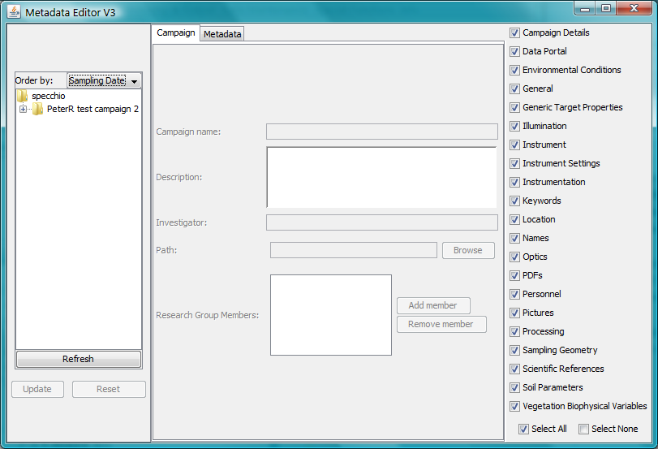

Figure : Metadata editor dialog

%%% Update to current app’s initial editing window and highlight with items listed here.

Campaign Tree Navigator Shows the Campaigns present in the data base and allows selecting of Campaigns, sub-trees and Spectra.

Order By Indicator Select the sort order to use for Spectra in the left hand Campaign navigation window.

Refresh button Click this button to update the Campaign Tree Navigator after making changes which affect it.

Update button Click this button to write all changed Metadata back into the database.

Reset button Click this button to ignore all changes made since the last time the Update button was clicked and redisplay the Metadata panel from the database.

Metadata selection tab Select either Campaign, to display and edit Campaign Metadata, or Metadata to display and edit Spectra Metadata.

Metadata display area This will show the Metadata selected by the Metadata selection tab.

Spectrum Metadata selection area Click on these checkboxes to display or suppress the various groups of Spectrum Metadata.

In this editor, whenever changes are made to any Metadata entries, they are saved in an action list. They are not written immediately to the database. When the Update button is clicked, the action list is processed and the database is updated.

When the Reset button is clicked, the action list is discarded without being processed and the content of the Metadata display area is redisplayed from the database.

Warning The action list is not processed in the sequence in which you made the changes. It’s processed in a sequence based on Specchio’s internal algorithms. If you make two changes to the one Metadata field, these two changes may be processed in the reverse order from what you made them. This will yield unpredictable results. Therefore, once focus has left a Metadata field, be sure to **click** Update **before returning the cursor to that field and making another change to it**. Making changes to two different Metadata fields is safe.

Metadata entry fields are of various types, including integer, floating point, alpha string, date/times or special lists. Generally, the editor restricts you to entering values which are consistent with the data type. However, the editor does not perform validation checks on entered data. For example, while you must enter a valid floating point number for the Relative Humidity, the editor will not reject negative values or values greater than 100.

Warning Take care to enter numbers which are within the valid range for the Metadata value you are entering. The editor will permit you to store values which are outside the valid range, which can have misleading or unpredictable results later.

### Editing Campaign Metadata

See section for detailed information about individual Campaign Metadata fields, their meanings and operation.

Click on the Campaign tab to highlight it and display Campaign Metadata.

In the Campaign Tree Navigator, click on the Campaign, or on anything in that Campaign’s sub-tree. The Metadata for that Campaign will be read from the database and displayed in the Metadata display area.

After making changes to the Campaign Metadata for one or more Campaigns, click on Update to cause these changes to be written to the database.

Clicking on Metadata group names in the Spectrum Metadata selection area does not affect the Campaign editing tab.

If you change the Campaign Name, click on the Refresh button to cause that change to be shown in the Campaign Tree Navigator.

### Editing Spectrum Metadata

See section for detailed information about individual Campaign Metadata fields, the way they are organised into Metadata groups, their meanings and operation.

In order to understand the operation of this Editor, it is helpful to understand how Spectrum Metadata are stored by Specchio. So that the space is optimised, Specchio only stores Metadata values which are set. They are stored in an Entity/Attribute/Value table, where one Metadata item is stored in each row of the table as an Attribute/Value pair (such as Latitude=-35.33943, or Ambient Temp=23.5). The Entity field in that row stores a list of those Spectra which are associated with this particular Attribute and Value.

Click on the Metadata tab to display Spectrum Metadata.

#### Editing Metadata for a Single Spectrum

Navigate to the Spectrum in the Campaign Tree Navigator. Click on it to highlight it and to display that Spectrum’s Metadata.

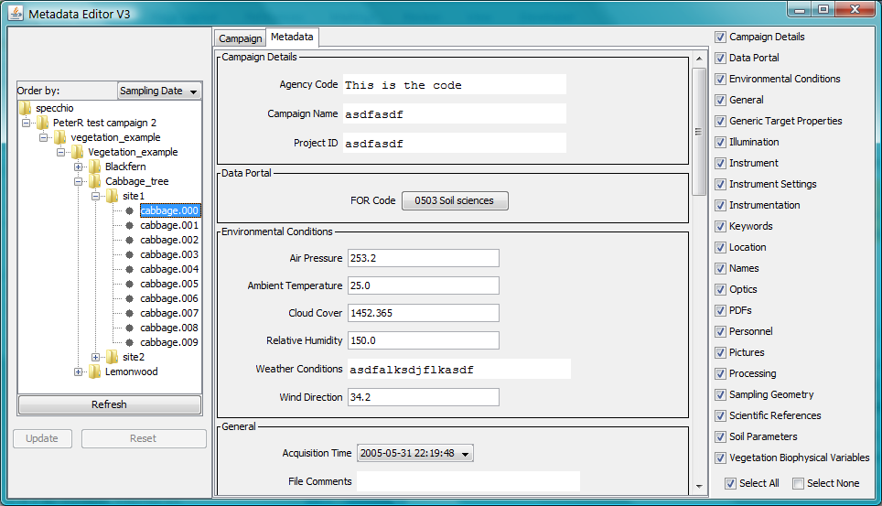

Figure : Metadata editor dialog

Values will only be shown for Metadata which are set for that Spectrum. Usually one or more Metadata group boxes will be empty for most Spectra.

Click on the Metadata group check boxes in the right hand panel to show or hide the various Metadata groups. Select All displays them all, and Select None hides them all.

Whenever a Metadata value is changed, if that metadata value is shared by more than one Spectrum, the following dialog will be displayed.

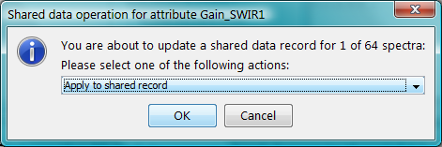

Figure : Shared data operation selector dialog

This dialog allows you to select how you want the Entity/Attribute/Value table to be updated when the OK button is clicked. The options are:

Apply to shared record The shared record in the Entity/Attribute/Value table will be updated and all spectra which share this Metadata value will be updated with this change. Understand how widely the shared record is referenced when you use this option. It is possible for it to be used for any other Spectrum in the entire database, although it is usually just used by other Spectra in the same Campaign.

Create new record for selected spectra Only the selected spectrum will be affected. To achieve this, Specchio will create a new entry in the Entity/Attribute/Value table and link only the selected spectrum to it. No other spectra will be affected.

Cancel update operation No changes will be made when the OK button is clicked. You should click on Reset to cause the original database values to be redisplayed.

If the Cancel button is clicked, no changes are made regardless of the selection made in the dialog. You should click on Reset to cause the original database values to be redisplayed.

To modify a Metadata value:

* Ensure the value to be modified is displayed. Navigate to the correct Spectrum, ensure that the check box for the required Metadata group is ticked and scroll to the Metadata group.
* Click in the field and edit it so that it contains the required value. When the field contains a valid value the Update button will become valid.
* Click on the Update button to write the change back to the database. If the Metadata is shared by more than one Spectrum, the dialog in Figure 30: will be displayed. Select your desired action and click OK.

To delete a Metadata value:

* Ensure the value to be deleted is displayed. Navigate to the correct Spectrum, ensure that the check box for the required Metadata group is ticked and scroll to the Metadata group.
* Right click on the name of the field you wish to delete. A Delete button will appear.
* Click on this Delete button. The Metadata field will disappear from the display and the Update button will become valid.
* Click on the Update button to write the change back to the database. If the Metadata is shared by other Spectra, the dialog in Figure 30: will be displayed. Select your desired action and click OK.

To add a new Metadata value:

* Ensure the required Metadata group for the correct Spectrum is displayed. Navigate to the correct Spectrum, ensure that the check box for the required Metadata group is ticked and scroll to the Metadata group.
* Right click anywhere in the Metadata Group’s display box. A menu of Metadata items that can be added for that group will be displayed.
* Click (left or right) on the menu entry for the Metadata item you wish to add. A data entry field for the Metadata entry will be displayed.
* Entry the value you require for this Metadata field.
* Click on the Update button to write this change back to the database.

Note Specchio allows changing of most Metadata fields, but for some fields it does not make sense. It could often be confusing and should not be done, except in unusual circumstances. For example, changing the File Name or File Format for a Spectrum does not make sense. Changing the Spectrum Number is also rarely meaningful and could often be confusing. Changing the automatically set Acquisition Time and Loading Time values will generally be confusing.

#### Editing Metadata for All Spectra in a Sub-tree of the Campaign tree

Specchio allows for simultaneous updating of Metadata for multiple Spectra. This feature is typically used when multiple Spectra have just been uploaded and a selection of their Metadata items shares the same values.

When any node in the Campaign Tree Navigator is highlighted, the Metadata values that are common across all Spectra under that node are displayed. Where the Metadata values are not common, the string -- Multiple Values -- is displayed. Where some but not all Spectra have a common Metadata value and the remainder have no value for that Metadata item, then %%% what happens?.

To change all values for a specific Metadata item for all Spectra under a node:

* Ensure the required Metadata group for the Spectra under the require Campaign tree node is displayed. Navigate to the correct node and highlight it, ensure that the check box for the required Metadata group is ticked and scroll to the Metadata group.
* Click in the field to be changed and edit it so that it contains the required new value. When the field contains a valid value the Update button will become valid.
* Click on the Update button to write the change back to the database for all Spectra for this node. If the Metadata value is shared other Spectra not under the scope of this node, the dialog in will be displayed. If you select Apply to shared record the will apply to all Spectra which share this Metadata value. If you select Create new record for selected spectra Specchio will create a new Metadata value which will be shared only by the Spectra which are under this mode. Select your desired action and click OK.

To reset a specific Metadata item for all Spectra under a node to have the same value:

* Ensure the required Metadata group for the Spectra under the require Campaign tree node is displayed. Navigate to the correct node and highlight it, ensure that the check box for the required Metadata group is ticked and scroll to the Metadata group. The value displayed in the Metadata field should be -- Multiple Values --.
* Right click on the Metadata field name to show a Delete button. Click on the Delete button. The Metadata field will disappear from the screen.
* Click the Update button to write this change into the database. (This step is critical – don’t skip it!)
* Right click within the Metadata group box to display a menu of items that can be added to this Metadata group. Click on the Metadata item to be added back.
* Entry the value you require for this Metadata field.
* Click on the Update button to write this change back to the database.

Warning There are some Metadata change operations which do not make sense when applied to multiple Spectra. These would include deleting the File Name of multiple Spectra, changing File Names to be the same, changing Spectrum Numbers to be the same, changing the Acquisition Time or Upload Time, or changing the File Comments would generally not be useful and could be confusing. It is recommended that Users give careful consideration to the logical validity of changing Metadata values for multiple Spectra before doing it.

#### Editing Metadata for Multiple Unrelated Spectra

The operations in the preceding section can be applied to multiple unrelated Spectra.

It is possible to add a Spectrum to the set of selected Spectra by holding the Control key while clicking on the Spectrum. It is possible to select a range of Spectra by selecting the first Spectrum and then holding the Shift key while you click on the last Spectrum in the range. (This is consistent with common usage of the Control and Shift keys.) The operations above will then apply to all selected Spectra.

Similarly, it is possible to select multiple notes in the Campaign tree and operate on all Spectra in those nodes.

Warning It is also possible to select multiple Spectra or nodes across different Campaigns and then update all selected Spectra to share the same Metadata values. This should not be done. If subsequent users select the Apply to shared record option when editing Metadata, it will change the Metadata across both Campaigns, which is a very unexpected and confusing result.

From JIRA DC10-164, Nick says...

I've modified the input validation code for numeric fields so that

* the cursor keys, delete and backspace can be used in any field
* digits and the minus sign can be input into any numeric field
* decimal points can only be typed into fields with a floating value type
* the "update" button is only enabled once the value in the field can be parsed
* all number format exceptions are caught and handled

At least one oddity remains. If the user changes a field to a valid value, the "update" button will be enabled. If the user later changes the field to an invalid value, the "update" button remains enabled. If the user then presses "update", the database will be updated with the last valid value that was in the field.

#### Overriding the Conflict Detection

%%% Does this exist in the new app?

The conflict detection that disables updates of non-shared data in spectra groups can be switched off by selecting the ‘Override conflict detection’ checkbox on the control panel (cf. Figure 31).

Be sure that you know what you are doing: all previously individual metadata of the selected spectra might be replaced with the new data. Overriding conflicts may lead to some unwanted effects; depending on what metadata parameter it is updated.

The critical ones are: position, environmental data and sampling geometry. For these, only existing entries will be updated, i.e. if a group of spectra is updated and one of these spectra has no previous position record, then no new record will be inserted. This effect is due to the database model and additional software logic would be required to handle these special cases.

If you use the conflict overriding option, check carefully the results of your updates!

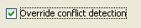

Figure 31: ‘Override conflict detection’ checkbox

#### Shared Field Colouring

%%% Does this exist in the new app?

Tick this checkbox (see Figure 32) to show which fields of the current spectra selection are shared with other spectra. It may help to understand what data is shared and what the effect of an update might be (update of shared records).



Figure 32: 'Highlight shared fields' checkbox

See Figure 33 for an example of shared field colouring. The spectrum ‘lemonwoo.004’ shares spectrum name and pictures with all other spectra under the ‘site1’ folder of the Lemonwood folder. The instrument information is not shared, as each spectrum has a direct link to the appropriate instrument.

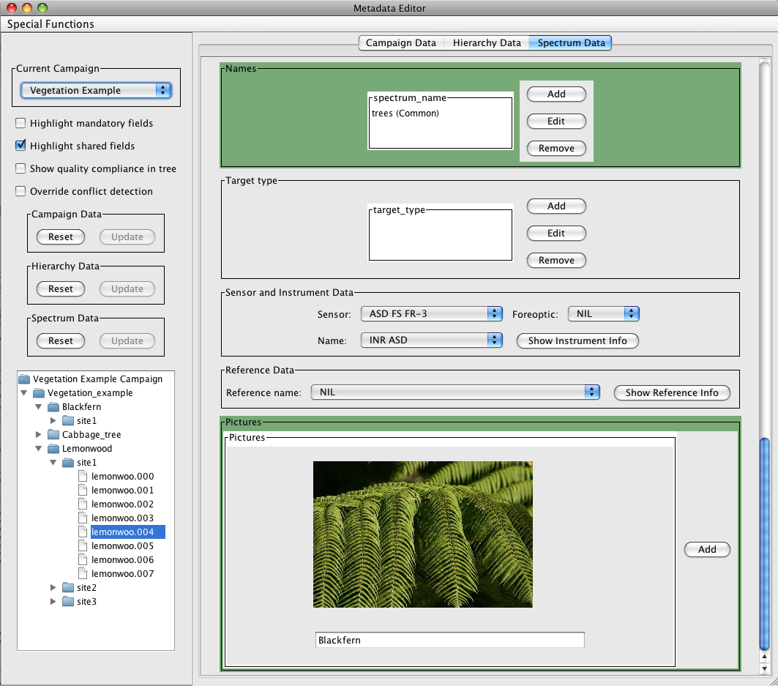

Figure 33: Example of shared field colouring

#### Mandatory Field Colouring

%%% Does this exist in the new app?

When a required quality level has been selected for a spectrum the mandatory fields can be highlighted (cf. **Error! Reference source not found.** for more information on metadata quality, cf. Figure 35 for an example of mandatory field colouring).

To use mandatory field colouring tick the ‘Highlight mandatory fields’ checkbox in the control panel (cf. Figure 34). Note that drop-down menus only show the highlighting when selecting a value.



Figure 34: ‘Highlight mandatory fields’ checkbox

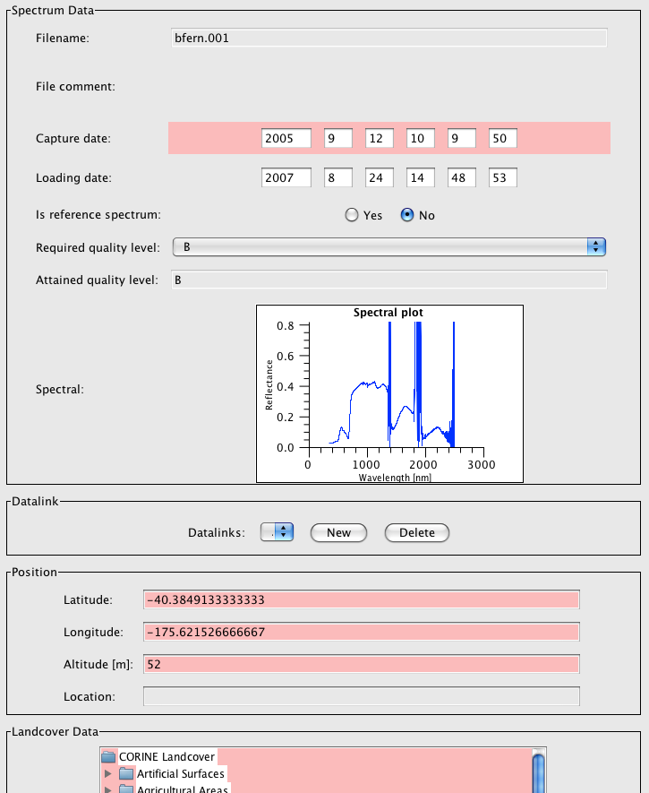

Figure 35: An example of mandatory field colouring

#### Showing the Quality Compliance in the Metadata Browser Tree

%%% Does this exist in the new app?

The metadata browser can display information about the quality compliance of the spectrum and the campaign. To switch on this option select the ‘Show quality compliance in tree’ checkbox in the control panel (cf. Figure 36).

Tree nodes that do not yet comply with the required quality level are indicated by an asterisk. Quality compliance is propagated upwards in the tree. If a spectrum does not comply then all parent hierarchies and the campaign itself will show an asterisk (cf. Figure 37 for an example).

Note that enabling this option reduces the responsiveness of the GUI as compliance checks have to be carried out on every metadata field.

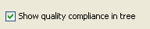

Figure 36: Show quality compliance in tree checkbox

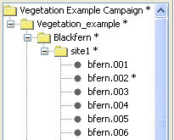

Figure 37: Quality non-compliance indicated by asterisks in the metadata browser

#### Definition of Data Links

%%% Does this exist in the new app?

Data links can be defined on spectrum and hierarchy level, i.e. spectra link to spectra and hierarchies to hierarchies. The definition of links is explained for spectrum datalinks hereafter. The definition of hierarchy datalinks is identical in terms of user interactions.

Clicking on ‘New’ right to the datalink list (cf. Figure 38) will open a new dialog (cf. Figure 39).

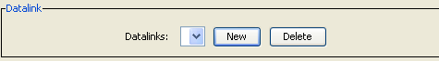

Figure 38: Datalink list and ‘New” and ‘Delete’ buttons

In this dialog use the spectral data browser to select the spectrum that shall be linked. The selected spectrum will be displayed in the right side in a read only field. Select the link type from the list box. Click ‘OK’ to create this link.

Note that the function ‘Link targets to references’ provides a quicker and easier option to create reference panel links (see 6.4.2.7.2).

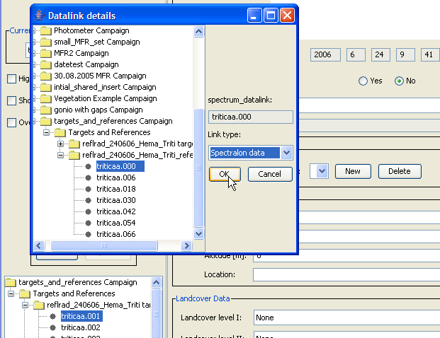

Figure 39: Definition of a datalink on spectrum level

#### Special Functions

%%% Does this exist in the new app?

The metadata editor provides some special data processing functions. They are either accessed via the metadata editor menu (cf. Figure 40) or via actions buttons in the spectrum tab.

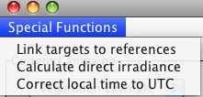

Figure 40: Metadata editor Special Functions menu

**Note**: The special functions offered by the menu do not depend on the currently selected campaign in the metadata editor but offer access to all campaigns.

##### Calculation of Goniometer Angles

%%% Does this exist in the new app?

RSL uses a standard protocol for the capturing of directional data using a goniometer (FIGOS/LAGOS). The sensor zenith and azimuth are given by the capturing sequence (Figure 41).



Figure 41: Data collection sequence of the RSL FIGOS/LAGOS system

A full directional set consists of 66 spectra. The routine expects a maximum number of 66 spectra, i.e. excessive spectra like white reference readings must be removed before the angles are calculated. The function can deal with gaps in the data, provided that the user can specify them. See Figure 42 for a screenshot of the dialog with the metadata editor in the background.

The following user actions are needed:

* In the spectral data browser of the metadata editor select a hierarchy that contains the spectrodirectional measurements. (cf. Figure 42 where the ‘target’ hierarchy has been selected in the metadata editor)
* Click the ‘Calc Gonio Angles’ button in the ‘Sampling Geometry’ section of the metadata editor. This will open the Goniometer Angle Calculation dialog. The selected hierarchy and the number of spectra is displayed in the according fields in the middle section of the dialog. If the wrong hierarchy was selected in the metadata editor, you can redefine your selection in the metadata editor while leaving the Goniometer Angle Calculation dialog opened. Changes in the spectral data browser of the metadata editor will be reflected within the Goniometer Angle Calculation dialog.
* If there are any gaps, specify the positions of the gaps in the Gaps input text field. The gap numbers must be separated with commas. Then click the ‘Insert gaps’ button and the total number of spectra plus inserted gap dummies will be shown in the read only field ‘Spectra + dummies’. Note that positions start with 0.
* Click ‘Calculate’. This fills the listbox one the right side of the dialog with a preview of the calculated angles. The line format is: <position>: <azimuth>/<zenith> <filename>
* Click ‘OK’ to insert the calculated angles into the database

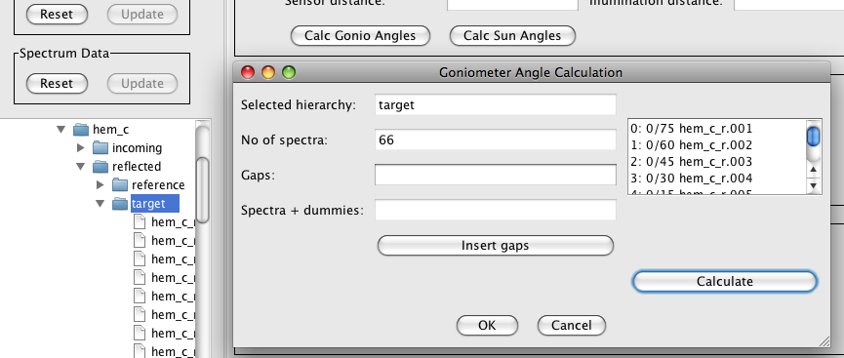

Figure 42: Goniometer angle calculation dialog

##### Linking Targets to References

%%% Does this exist in the new app?

This dialog can be used to automatically create a datalink of the type ‘Spectralon’ between target spectra and white reference spectra.

This function is applicable for campaigns where target and reference spectra are collected in separate spectral files. This is e.g. the case for campaigns utilising the ASD spectroradiometer in radiance mode. In order to tie the target to its corresponding white reference spectrum, a datalink on spectrum level must be inserted. This could be achieved manually for each spectrum using the metadata editor.

Target and reference spectra are ideally stored in separate hierarchies, but they can also exist in a mixed state. The example shown in Figure 43 is taken from a goniometer campaign. In the left spectral data browser select the hierarchy or spectra containing the targets. In the right browser select the hierarchy or spectra containing the references. The selected spectra are displayed in the read only fields on the right side of the dialog. The two text fields at the bottom of the spectral data browsers can be used to specify filename restrictions, e.g. entering ‘%00%’ for the targets only selects the files triticaa.001 - triticaa.009

Click link to create datalinks between targets and references.

Details on the algorithm:

The linking utilises the capture time stamps of the spectra. Consider two timelines: one for the targets and one for the references. A target must link to the reference with the smallest absolute delta time (see Figure 44).

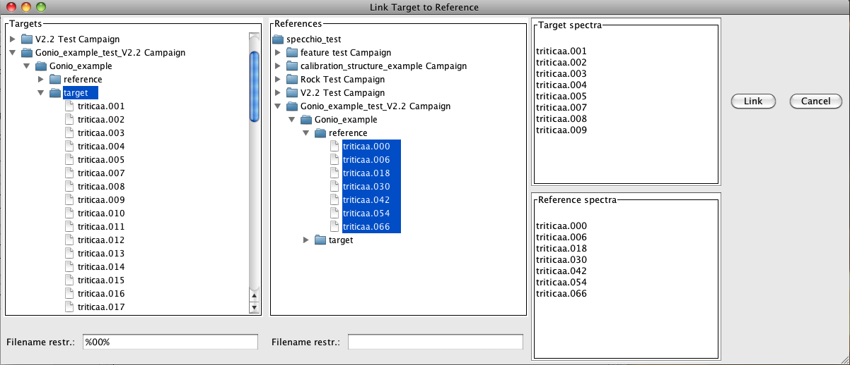

Figure 43: Link Target to Reference dialog



Figure 44: Referencing of reference panel spectra by target spectra based on timeline information

##### Calculation of Sun Angles

%%% Does this exist in the new app?

The sun angles are stored as part of the sampling geometry, namely as illumination zenith and azimuth. Sun angles can be calculated for a spectrum if the spatial position in latitude/longitude and the capture time in UTC are known.

Select the spectra to be processed in the spectral data browser of the metadata editor (see Figure 45). Note that any selection (single spectra, hierarchy and mixed cases) is possible.

The sun angle calculation dialog opens and the number of spectra is displayed. Click OK to calculate the sun angles and store the results in the database.

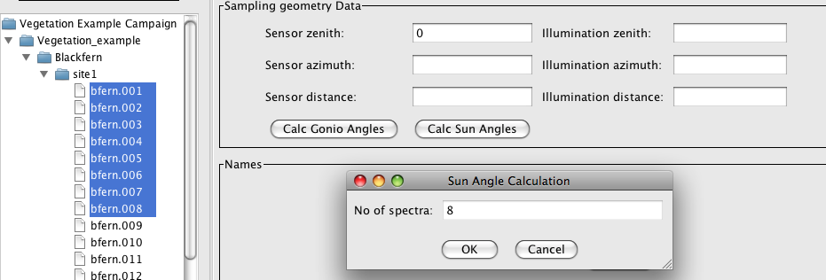

Figure 45: Sun Angle Calculation dialog

##### Direct Irradiance Calculation

%%% Does this exist in the new app?

The calculation of direct irradiances applies to photometers where the total and diffuse irradiance are known. Total and diffuse spectra must be stored in separate hierarchies (see Figure 46).

Furthermore, all spectra need to have a defined sun zenith angle. A message box is shown if sun zenith angles were not found.

The calculation cannot be carried out on hierarchies already containing a ‘direct’ hierarchy. If a recalculation is needed first remove the ‘direct’ hierarchy from the database using the ‘Data Remover’ dialog.

Select the hierarchy containing the total and diffuse hierarchies. Note that they must be named ‘total’ and ‘diffuse’. This will be auto generated in the case of MFR file input. The selected hierarchy and the number of total/diffuse spectra pairs will be shown.

Click ‘OK’ to calculate the direct irradiance. A new hierarchy will be created called ‘direct’ (see Figure 47) containing all direct irradiance spectra.

Details on the algorithm:

For each channel i: direct\_irr[i] = ((tot\_irr[i] - diff\_irr[i])/cos(sun\_zenith));

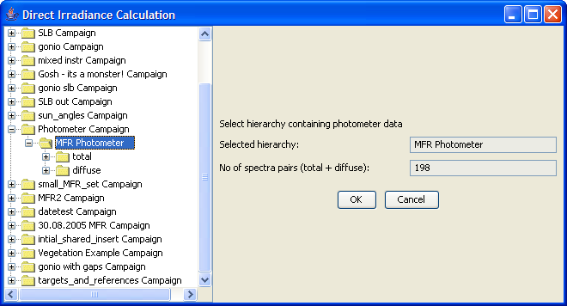

Figure 46: Direct Irradiance Calculation dialog

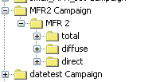

Figure 47: Direct irradiance hierarchy

## UTC Time Correction

This tool is provided to handle cases where the capture time was not recorded in UTC. It applies a time shift based on the number of hours entered by the user in the UTC Time Correction dialog (see ).

Select the hierarchy containing the spectra that need to be time shifted. The selected hierarchy and the number of spectra are shown on the right in read only fields. The hours are specified as East of GMT (that is, the number for Australia will be positive).

As date/time fields are stored in milliseconds, the time shift is implemented as:

Date\_time\_in\_milliseconds = Date\_time\_in\_milliseconds – hours\_east\_of\_gmt\*milliseconds\_per\_hour.

Therefore, if a time shift happens across midnight, the calendar date of the capture time will also be shifted back or forth, depending on whether hours\_east\_of\_gmt is positive or negative. For example, for a local capture time around 10am in Oceania a time shift of around 12 hours East of GMT is needed. The UTC time will then be 10pm the previous day.

A Time Shift Metadata attribute in the Processing Metadata group is added to each Spectrum that has its Acquisition Time adjusted by this function.

Warnings Applying a time shift twice will be difficult to detect and difficult to undo. Do not click the UTC dialog’s  OK  button a second time.

Selecting both a Spectrum and a parent hierarchy node of that Spectrum will cause the time shift to be applied to the Spectrum twice. Similarly selecting a hierarchy node and a parent of the hierarchy node will cause all Spectra under the lower hierarchy node to have the time shift applied twice. Also, selecting three items above one another in the hierarchy will result in the correct being applied three times.

The Time Shift Metadata attribute is set only the first time a time shift is applied to a Spectrum. Subsequent uses of the UTC Time Correction on the Spectrum will further adjust the time, but the Time Shift Metadata attribute is not updated for subsequent times.

%%% Are the above warnings still true or has the related JIRA issue been actioned?

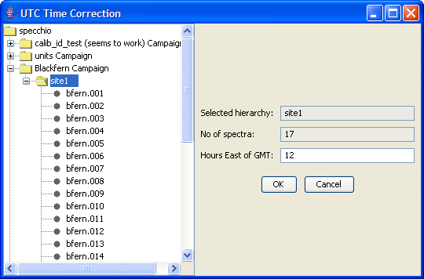

Figure 48: UTC Time Correction dialog



Figure 49: Time Shift Metadata Attribute after applying a UTC Time Shift

## Uploading Metadata from Excel files

%%% I can’t get this function to actually load anything, even though it claims to have done it. Inspecting the spectra after loading shows that no new Metadata exists. JIRA Issue DC10-179.

%%% Presumably this function creates one Entity/Attribute/Value record for every value it reads and assigns it to just one Spectrum. Not very efficient. Will this create a performance problem if there are large amounts of uploaded data? Is a warning needed in the manual?

%%%% Second file gives a matching between column names in the first Excel file, and the attribute names within Specchio. See example files – ask Nick.

%%% Does this support CSV too? It’s probably same as other Excel load options in Specchio as it will use the same library. It appears it can’t handle .xlsx files.

Specchio supports uploading Metadata to your Campaign from files saved as Excel 95, 97, 2000, XP, and 2003 formats.

Specchio reads the Excel file one row at a time, matching the data in a designated column to a selected data item in the spectra from the Campaign to which you are uploading. The remaining data in that row are then set into designated Metadata fields for the matched spectrum. The matching process is performed using regular expressions. (See Appendix for information on regular expressions.)

Metadata Excel files must conform to the following conventions in order to be loaded correctly.

* The first row must be a column heading row. It will be displayed during the upload process, but it will not be uploaded.
* Each subsequent row must contain data which will be uploaded as Metadata to one spectrum.
* One column, identified at upload time, will be used to match some existing Metadata element to identify the spectrum to which the new Metadata in that row will be applied.
* Other columns contain the Metadata that will be uploaded.
* Columns can be ignored during the upload process.

If you wish to use Auto-Matching of Elements and Columns, then you need to prepare an additional Excel file. This file %%% what is it for and what is its structure?

To upload Metadata, create and save an Excel file containing the Metadata to upload. Then follow these steps.

* Select Data input and Get metadata from XLS from the menus on the Specchio Main Window. The following dialog will be displayed. Only those Campaigns to which you have write permission will be displayed.

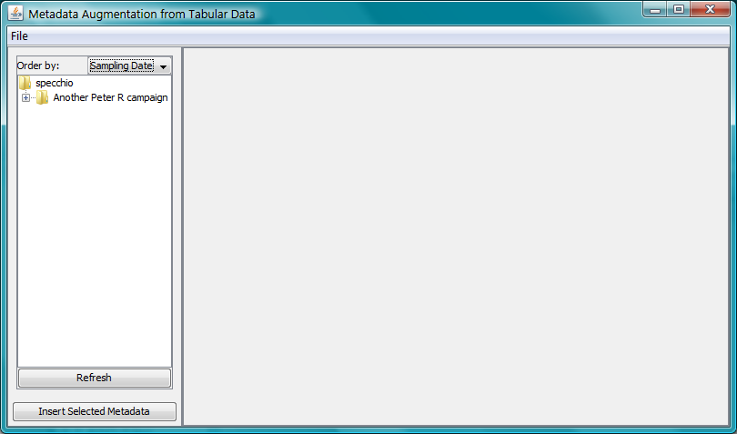

Figure : Metadata upload initiation dialog

* Click on the Campaign to which you want the Metadata to be uploaded to highlight it. (It is important to select the Campaign before opening the file, because the loading parameters are set up based on this Campaign as the file is read. The file cannot be uploaded if the Campaign is selected after opening the file.)
* Select File and Open file... from the menu bar on this screen. A standard file selection dialog will be displayed. Browse to the Excel file you have previously prepared and Open it. The file will be read and the dialog will be augmented and appear similar to the following.

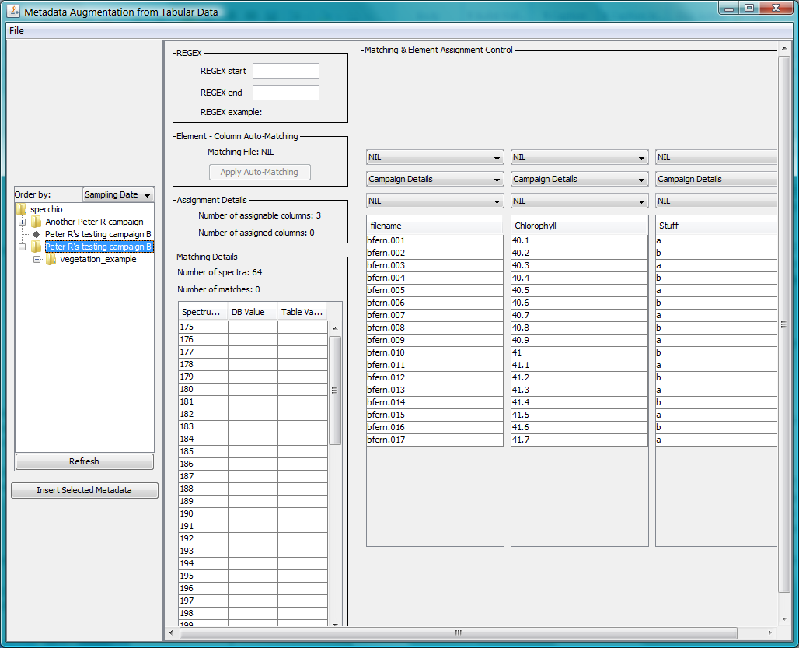

Figure : Metadata upload dialog after file open

There will now be three panels in this view:

Left The Campaign browsing panel as previously displayed

Centre A parameter panel, which also lists some details from this Campaign, including a list of its Spectra in the Matching Details box

Right The Matching & Element Assignment Control panel, which shows the content of your Excel file and allows you to identify how each column will be processed

* Optionally, if you wish to use Element – Column Auto-Matching, select File and Open Column Element Matching File... from the menu bar on this screen. A standard file selection dialog will be displayed. Browse to the Excel file you have previously prepared and Open it. The name of this file will appear in the Element – Column Auto-Matching box in the centre panel, and the Apply Auto-Matching button will be activated.
* In the right hand panel, review the data. Correct any values you wish by double clicking on them and entering your modified value.
* In the right hand panel, identify the Excel file column that will be used to select the spectrum into which each row of the Excel will be uploaded. Set the top dropdown box in this column to show Matching Column. The top dropdown box for all the other columns must be left showing NIL.
* In the Matching Column you have just identified, use the second dropdown list to select the category from which you want the matching metadata item to be chosen. (Note that File name is under General.) Verify that the Matching Details box in the centre panel updates to show the Number of matches that you expect.
* In the Matching Column, then select the metadata item which will be used to match.
* In each of the other columns that you wish to upload, use the second and third questions to identify the metadata item which will be loaded with that data. If you leave the third question for any column set to NIL, that data in that column will be not be uploaded.

As you update the answers to these questions, various values in the centre panel will change to reflect your selections. In particular, the numbers in the Assignment Details box will change.

* If you wish to augment the regular expression matching strings that will be used for matching the contents of Matching Column you have selected, you can add strings that will be joined before and after the string read from your Excel file prior to its use for matching. Enter the strings into the REGEX start and REGEX end fields of the REGEX bos in the centre panel. The resulting matching string taken from the first data line of your Excel file will be shown in this box as an example.
* Click on the Insert selected metadata button in the left panel to cause the metadata to be loaded. (%%% How do you know it did it correctly? Why doesn’t the dialog exit? What happens when you change the values in the Spectrum column of the Matching Details box? What happens if you change them all to the same, or to values for which there are no spectra? Is it a catastrophe if you click Insert selected metadata again?)
* Close the Metadata upload dialog by clicking on the usual window close control for your operating system.

# Data Query and Output

## Specchio’s Spectrum Browser

%%% Describe its purpose and general form.

The data displayed in the Spectral Data browser can be restricted to the data of the current user by clicking the tickbox ‘Show only my data.’ (see Figure 52). %%% Is this still supported? If so , how? It seems to always show all data.

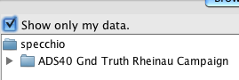

Figure : Restricting the data displayed in the spectral data browser to the current user

For the options ‘Spectral Plot’ and ‘Process’, the building of spaces can be controlled by switching on/off the ‘Space split option’: if selected, spaces will only be created per sensor type and measurement unit, if deselected, spaces will be created per sensor type, measurement unit, instrument and instrument calibration.



Figure : Query Builder dialog

%%% The above has both tabs’ functions joined into one dialog with a tab method to separate them, and an SQL query displayed. It allows restriction to only my data. Similarly to metadata edit, the metadata descriptions are more comprehensive than my app.

%%% What is Refl Calc – not in doc? %%%% “Reflectance Calculation” – radiance to reflectance transformation – sets up processing steps instead of doing it manually.

%%% What is MSD – not in App? Andy says not implemented in current version.

## Querying Data

Specchio’s Query Builder provides a way to select one or more Spectra based on their Metadata, and then to do operations on all of these selected Spectra. These operations include ‘Show report’ ,‘File export’, ‘Process’ and ‘Spectral Plot’. All supported operations are described in the sections 8.3 or later in this Chapter. %%% And also Space Networks, which are described in Chapter 9. Simplify this manual structure, if possible.

To start the Query Builder select Data Processing & Output and Build query from the menu on Specchio’s Main Window.

%%% Has the SQL output been abandoned? I can’t see it. Is this a consequence of the interposing of a HTML interface between the app and My SQL?

Actions on both of these tabs will result in the automatic building of an SQL query. The query is updated in real time on each user input. The number of resulting rows (should the query be executed) is displayed and updated along with the SQL query. The query can be copied from the text area for e.g. direct execution in an SQL prompt.

%%% The following does not look right. Review the app’s execution to describe what now happens.

The query conditions tab is grouped similarly to the Metadata Editor.

The basic query GUI components are:

* 1. Simple combobox : One out of several options can be selected. The default ‘All (incl. none)’ imposes no restriction on the rows to be returned.  
       
     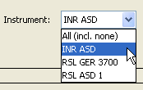
  2. Combobox with wildcard box: One of several options in the combobox can be selected. Alternatively a wildcard string can be entered in the wildcard box. Standard SQL wildcards can be used. These are: % for any string expression and \_ for one character. Note that when selecting a combobox entry the wildcard string is automatically blanked. Similarly, if a specific combobox entry is selected and wildcards are entered the combobox reverts to the default ‘All (incl. none)’.  
       
     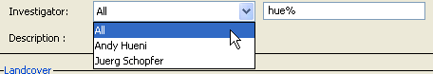
  3. Wildcard text field: This takes any SQL wildcard string  
       
     
  4. Numerical field with buffer: This consists of a main numerical field and a buffer that, when filled generates expressions of the type: field\_name >= main\_value – buffer AND field\_name <= main\_value + buffer.  
     When applied to e.g. spatial metadata like latitude, the effect is similar to buffering functions found in GIS systems.  
       
     
  5. Multiple selection list: 0:N elements can be selected/deselected from the list by using ctrl and the mouse button. Note that the expressions built from the selected elements are logically related by OR and not by AND. I.e. the resulting expression has the SQL syntax ‘field\_name in (<id> [, <id>])’.  
       
       
     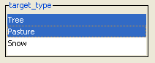
  6. Time restrictions: these are set by selecting start and end dates. Time restrictions are easily reset my clicking on the reset buttons.  
       
       
     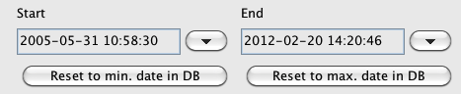
  7. Generic Metadata restrictions: from SPECCHIO version 2.2.0 onwards, a further query field to search for specific data in the generic metadata table is included. To add another query condition, click on “add condition” and select a field from the drop down menu. You can search specifically for a certain value by using the equals operator “=” or for similar entry with the “Like” operator and by using standard SQL wildcards (%, \_). You can combine as many such conditions as you want. To remove one condition, right click on the condition and select “remove condition”.  
       
     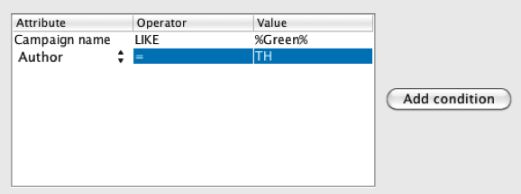

Figure 54 and Figure 55 show the query condition tab with some of the fields filled. The SQL query resulting from these entries is as follows:  
  
SELECT count(\*)

FROM spectrum, campaign, specchio\_user, position, sampling\_geometry

WHERE (specchio\_user.first\_name like 'spe%' OR specchio\_user.last\_name like 'spe%') AND spectrum.landcover\_id = '49' AND (position.latitude >= -50.0 AND position.latitude <= -30.0) AND (position.altitude >= 30.0 AND position.altitude <= 70.0) AND (sampling\_geometry.illumination\_zenith >= 40.0 AND sampling\_geometry.illumination\_zenith <= 50.0) AND spectrum.measurement\_unit\_id = '1' AND spectrum.illumination\_source\_id = '1' AND spectrum.instrument\_id = '1' AND spectrum.campaign\_id = campaign.campaign\_id AND spectrum.user\_id = specchio\_user.user\_id AND spectrum.position\_id = position.position\_id AND spectrum.sampling\_geometry\_id = sampling\_geometry.sampling\_geometry\_id AND campaign.user\_id = specchio\_user.user\_id AND specchio\_user.user\_id = position.user\_id AND specchio\_user.user\_id = sampling\_geometry.user\_id

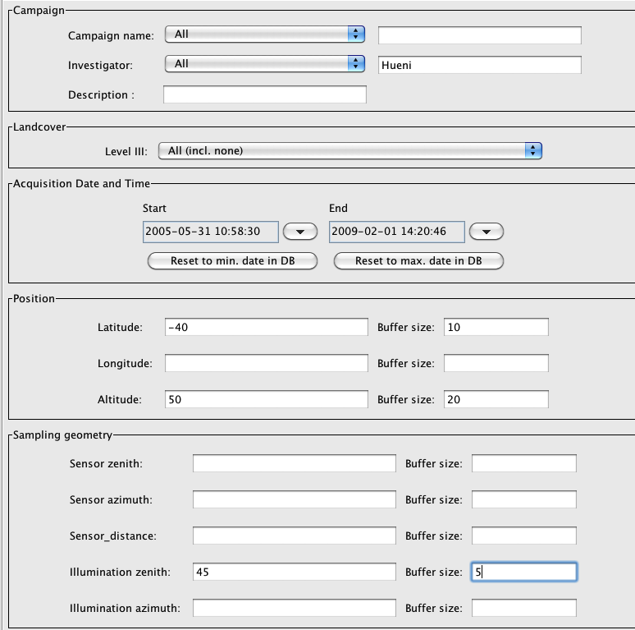

Figure 54: Query conditions tab (part 1)

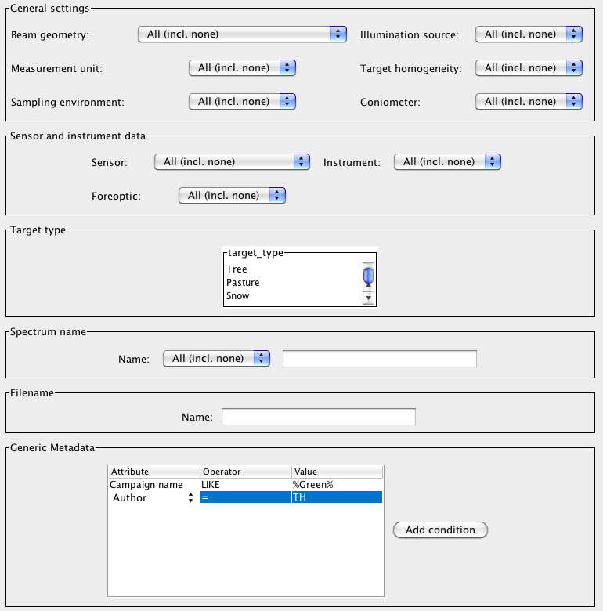

Figure 55: Query conditions tab (part 2)

## Report Generation

Reports are generated by selecting the ‘Show report’ button in the Query Builder (see ).

The report consists of a Java frame displaying the first of the spectra reports, as shown below.

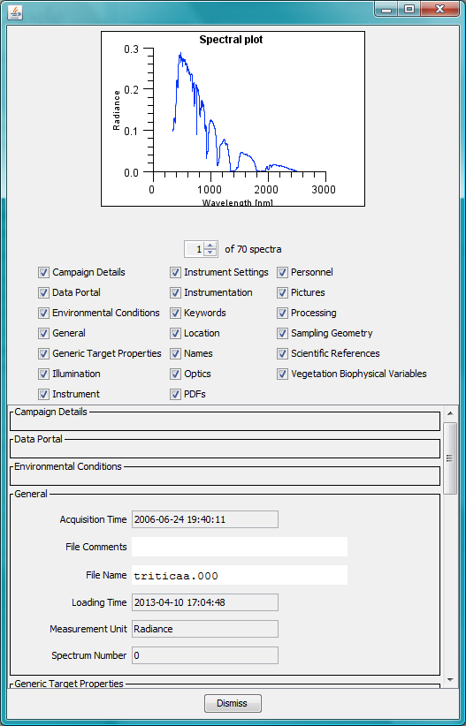

Figure : Spectrum report frame

Just below the Spectrum graph, the number of Spectra graphs in the report is shown with a control to allow you select which Spectrum graph you wish to display.



Figure : Spectrum Graph selection control

Click on the up and down arrows to cause the spectrum graph display to cycle through the available spectra. The selected graph is displayed after a short processing delay.

Specchio scales the graph’s Y Axis for Spectra with Measurement unit set to Reflectance to display correctly even when there is strong atmospheric noise in the usual regions of 1350-1440nm, 1790-1980nm and 2360-2500nm. For these graphs, the maximum Y value is set by calculating the mean and standard deviation in the wavelength region 300-1200nm and then setting...

Max Y Axis value = Mean + 3 \* StdDev

Spectra having no sensor definition are be plotted.

For sensors comprising broad and narrow band elements (e.g. MFR) only the narrow bands will be plotted.

Below the Spectrum Graph selection control are the Metadata selection check boxes.



Figure : Spectrum report frame Metadata selection

Check or uncheck these boxes to cause the related Metadata to be displayed in the Metadata display panel which is immediately below these check boxes. The changes are reflected in the display after a short processing delay.

%%% Maybe not up to date. Pictures or PDFs saved for a spectrum can be displayed by clicking on the Show pictures or Show PDFs buttons in the respective Metadata sections. This will bring up a new frame containing all pictures of this spectrum (see Figure 59).

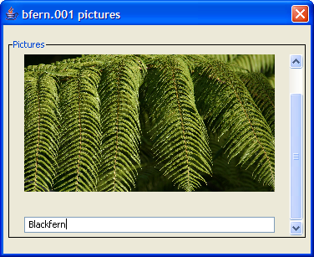

Figure : Spectrum report picture frame

## File Output

%%% File output does not seem to be supported in my app. Is this because the Show Report function is changed and the functionality has been removed? From later in the doc, I note that there is a File Export option next to Show Report, so maybe the doc is just wrong on this point.

File output is invoked by selecting the ‘Show report’ button in the Query Builder (see 6.6). A File output dialog will appear (see Figure 60).

Two file formats are currently supported:

* CSV: data is written to a text file as comma separated values. This file type can be e.g. read into Excel
* ENVI SLB: ENVI spectral library file consisting of a header (<file\_name>.hdr) and a body (<file\_name>.slb). Spectral data are written as floating point values, either 32bit or 64bit depending on the architecture of the machine; the datatype field in header file is set accordingly (datatype 4 or 5 respectively).

A target directory must be specified by clicking on the ‘Browse’ button. All files that are created during file output will be written to this directory. Note that when using a UNIX system you may have to enter a dot as filename (cf. **Error! Reference source not found.**).

A base name must be specified. This name should contain no characters that are not allowed in filenames (depending on the operating system). The base name is used to build the real filenames.

Filenames use one of the following patterns:

<base name>\_<sensor\_name>.<file extension>

<base name>\_<instrument\_name>[cal<calibration sequence number>].<file extension>

If no instrument has been defined the sensor name will be used.

If an instrument has a defined calibration then the calibration sequence number is added to the filename. If the spectra being written have been captured with different instruments or different calibrations then for each combination of instrument and calibration a separate file will be written.

E.g. consider a campaign containing spectra captured with:

* An ASD instrument belonging to the Institute of Natural Resources, Massey University (named INR ASD) with calibration sequence number 1
* An ASD instrument belonging to the Remote Sensing Laboratories, University of Zurich (named RSL ASD 1) with no calibrations entered in the database
* A GER 3700 instrument belonging to the Remote Sensing Laboratories, University of Zurich (named RSL GER 3700) with no calibrations entered in the database

A CSV file output of this campaign with the option ‘Split header and body’ results in the following files:



The option ‘Split header and body’ is only available for CSV files (ENVI SLBs are automatically split into header and body).

Two time formats are possible. Select the Milliseconds if you easily want to plot a timeline.

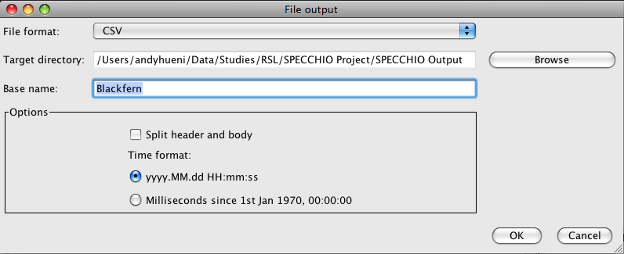

Figure 60: File output dialog

### CSV File Format

The CSV file format contains a header and a body. If the file is not split then header and body are written into the same file.

Metadata are essentially adding dimensions a dataset, i.e. the total dimension is given by: number of spectral bands + number of metadata fields. The dimension of an output file is therefore:

Number of rows (lines) = total spectrum dimension

Number of columns = number of spectra + 1 dimension name column

The line format is specified by:

<dimension name>, <value>[,<value>]

A file example showing part of a header and body follows (Figure 61):



Figure 61: CSV file example (loaded into Excel)

# Publishing Data to ANDS

%%% It’s any selection of files in the query builder.

%%% What information is copied to the RIF-CS?

%%% Can you Publish without a FOR Code? It would appear yes, and each Spectrum can have a different code.

%%% What happens when the Publish action fails? It appears that the internal flags say it was Published?

%%% Can you search on the Published ID?

%%% When Publishing multiple times, only the details of the last Publication are saved in the Spectra Metadata, and it’s saved per Spectrum.

# Interactive Processing using Space Networks

For an introduction to the concept of the Space Processing Network please refer to section .

Pressing the Process button in the Data Hierarchy Browser or Query Builder starts this processing tool. The window below appears.



Figure : Space Network Processor interface with the Query Builder in the background

A number of spaces are placed on the processing plane of the Space Network Processor, depending on the query built in Query Builder.

shows a space containing 66 spectra, created based on a selection in the Query Builder.

Figure 63 shows the common elements of the Space Network Processor: processing plane, spaces, edges, context sensitive menu of the processing plane and the Run button.

:::Plots and Graphs and Screenshots:Space Network Processor.pdf

Figure 63: Elements of the Space Network Processor

## Graphical Representations of Spaces and Modules

Spaces are depicted as rectangular boxes as shown here.



Figure : Examples of the graphical representation of a space (left) and a processing module (right)

Each space displays the following information:

[Integer] A unique number (zero in the example below)

Type A space type, which can be ‘Sensor/Instrument Space’ if loaded from the database or ‘Spectral Space’ if generated by a processing module.

D A dimension D, which is equal to the number of spectral bands of the spectra held by this space

# Vectors A number of vectors, which is equal to the number of spectra held by this space

Modules are also depicted as rectangular boxes, but their contents are quite different.



Figure 65: Examples of the graphical representation of a space (left) and a processing module (right)

Proc. module A module name

Settings Information about the configuration (if applicable)

Status The current processing status (text and progress bar). During processing, the progress is shown by the progress bar.

Spaces and modules can be rearranged by dragging with the mouse. The edges are updated automatically.

A group of elements can be moved as single block. Select the elements by dragging a box around them using the mouse, then drag the selection (Figure 66). %%% How are selected boxes identified, and what element do you need to drag to be effective? Can boxes overlap or obscure one another?



Figure 66: Multiple-selection of elements after dragging a box around them

## Adding Modules and linking with Spaces

To add a module, click the mouse menu button over some empty area of the processing plane. This brings up the context sensitive menu shown in . Select ‘Add Module’ and a selection of the available modules will appear (). Select one of the modules, click ‘OK’ and a new module will be added to the processing plane.

To connect the module with an input space, click the menu button over the module. This displays the popup menu of the module (). Select ‘Set Input Spaces’ and in the ‘Input Space Selection’ dialog select the number of the space to connect and click ‘OK’ (). Note that all spaces are given a unique number, which is located on the top left of each space. Connecting an input space automatically generates an output space, which is added to the processing plane and connected with the module.



Figure 67: Module selection dialog

 

Figure 68: Popup menu of a module (left) and the input space selection dialog (right)

## Configuration of Modules

Some modules may need configuration. To display the configuration dialog of a module click menu over the module and select ‘Configure’.

The possible configuration settings of each module are detailed in the respective module description.

## Processing Module Descriptions

%%% Maybe these sub-sections would be better set up consistently, perhaps in a table...

|  |  |
| --- | --- |
| Inputs: | Two Input Spaces:  A:  B:  Restrictions: |
| Outputs: | One Space |
| Processing: | Computes Radiance from Reflectance by reference to a Spectralon reference panel. |
| Prerequisits: | Datalinks of the type ‘Spectralon’ must exist between the target spectra and the corresponding reference spectra. |
| Note: |  |

### Radiance to Reflectance Transformation

The module ‘Radiance to Reflectance’ is building ratios of target and reference panel radiances:



As a prerequisite, datalinks of the type ‘Spectralon’ must exist between the target spectra and the corresponding reference spectra. For an explanation of how such links are created please refer to . %%% Are links supported in this app? Do you have to link to two spectra boxes? What if their D values are different?

### Reference Panel Correction Factors

This module retrieves the correction factors for all reference panels that were used during data acquisition of the spectra contained by the input space.

As prerequisites, a reference panel must be set for the input spectra using the Metadata Editor () and calibration data for the panel must have been loaded to the database. Calibration data loading is a task of the system administrator. For details on the reference panel administration see .



Figure 69: Reference panel setting in the Metadata Editor

If no calibration data can be found, a warning is displayed and the module creates no output space.

shows a processing chain that selects the panel correction factors and plots using a spectral line plot ().



Figure 70: Processing chain selecting the correction factors and plotting them as a spectrum.



Figure 71: Reference panel correction factors

### Correct for Reference Panel Non-Idealness

This module applies calibration factors to correct spectra for the reference panel non-idealness. These correction factors are selected from the database using the ‘Reference Panel Correction Factors’ module.

The module requires two inputs: the spectra to be corrected and the correction factors. The input space selection dialog offers the according choices ().



Figure 72: Input space selection for the ‘Correct for Panel’ module

Note that the dimensions of the spaces holding the spectra and correction factors must be identical (a check on the wavelengths is not carried out). In the example shown in a waveband filtering is applied to the correction factors as these were measured with a larger wavelength range.



Figure 73: Space Processing Network for reference panel correction

The panel correction can be applied to radiance or reflectance values. However, correcting radiances for the panel will only make sense if followed by a radiance to reflectance conversion such that:



The correction procedure can handle multiple reference panels and multiple calibration coefficients and will apply the correct coefficients to the appropriate spectra.

### Delta

This module calculates a delta value, i.e. the difference between two inputs A and B:

Delta = A – B

where:

A, B = MxN matrix of M spectra of dimensionality N

Thus, a delta vector is calculated by:



where m = {1…M}

This implies that the input spaces must have identical number of vectors and dimensionalities.

The delta module takes two input spaces ():



Figure 74: Input space selection for the Delta module

A possible use is the calculation of the difference between recorded reflectance and reference panel corrected reflectance. Figure 75 shows a processing network for this purpose and Figure 76 shows the according spectral plots generated by the network.



Figure 75: Space Processing Network for the panel correction and delta calculation

|  |  |  |
| --- | --- | --- |
|  |  |  |

Figure 76: Spectral plots of: input spectrum (left), panel corrected spectrum (middle) and delta spectrum (left)

### Waveband Filter

Waveband filtering is used to cut wavelengths regions from spectra. A typical example is the removal of noisy wavebands caused by water vapour absorption.

The wavebands are freely configurable. The ‘Configure’ menu brings up the ‘Filter configuration’ dialog ().



Figure 77: Filter configuration window

To add a new filter region, click ‘New’ and enter the upper and lower wavelengths in nanometres in the Filter Definition dialog (Figure 78).



Figure 78: Filter definition dialog

To remove an existing filter region, select the region in the list and click ‘Remove’.

### Broadband and Narrowband Filters

The filters act on the element type of sensor elements. They are useful to process data of sensors that contain bands widely differing spectral resolutions.

An example is the MFR sunphotometer, which features one panchromatic band and 6 narrower bands. The value ranges of the broad and narrow bands are very different and even a simple plot cannot be created satisfactorily (see ). The broadband channel has been placed at the likely centre wavelength of 673nm. As the bands of the MFR are defined in the order of the broadband followed by the narrowbands in the database, the plot shows two spectral lines. Mixing broad- and narrowbands should not be done from a physical point of view.



Figure 79: Spectral plot of broad- and narrowband MFR channels

Figure 80 shows a space processing network that illustrates the function of broad- and narrowband filters.



Figure 80: A space processing network demonstrating the function of broad- and narrowband filters

The plot shown in was generated by the ‘Spectral Line Plot’ of space number 0.

shows the plots of space 2 (Broadband value as a scatter plot) and space 3 (Narrowband channels as a spectral curve).



Figure 81: Plots of the narrowband channels (left) and of the broadband channel (right)

## Visualisation Modules

Visualisation modules can be attached to any space and do not generate an output space but display a new window containing the respective plot or data explorer. A visualisation module can be configured to produce a number of plots/explorers as listed in the following sections. Data explorers are graphical components that allow interactive data exploration.

The titles of the plot windows do contain information about the plot type and the space the data was read from ().



Figure 82: Information displayed in the window title

### Spectral Line Plot

Use this plot to display one or more spectra as continuous curves. Spectra are plotted with an automatic colour shift from red to blue for easier interpretation.



Figure 83: Spectral line plot of snow avalanche reflectance spectra

### Spectral Scatter Plot

Use this plot to display values per spectral band as singular points. This is useful to plot e.g. data of sensors with just one band, e.g. MFR broadband, as single values cannot be visualized as line plots. Scatter plots are also useful to show the variation of the values per band. shows an example of the variation per channel for several MFR sunphotometer readings.

**Note**: the generation of scatter plots of several spectra with high dimensionality tends to be quite slow.



Figure 84: Scatterplot showing the variation per channel for several MFR sunphotometer readings

### Gonio Sampling Points Plot

Use this plot to visualise the sampling positions of directional measurements acquired by a goniometer system. The plot is not expecting any specific number of points or particular geometry.

The sampling points are projected from their angular definition (zenith/azimuth) onto a 2d Cartesian coordinate system ().



Figure 85: Goniometer sampling point positions

### Gonio Hemisphere Explorer

The Hemisphere Explorer allows the interactive exploration of a spectrodirectional dataset, typically acquired by a goniometer system. shows an explorer window displaying a LAGOS (Laboratory goniometer system) dataset (Schopfer 2008).



Figure 86: Gonio Hemisphere Explorer window

The explorer window comprises a number of components interacting with each other as described hereafter.

The hemispherical plot () displays an interpolated surface of a specific wavelength. Clicking the icon in the top-left of the plot brings up a control panel for plot adjustments (rotations).

 

Figure 87: Interpolated 3D plot for a chosen wavelength (left) and rotation toolbox to manipulate the 3D plot

Use the band selection slider to select a spectral band for display (Figure 88). The wavelength text field below is reflecting the wavelength of the chosen band. Selecting a band triggers a re-plotting of both hemispherical plot and spectral plot.



Figure 88: Band selection slider and wavelength text field

The sampling points plot shows the sampling point positions projected onto a 2d Cartesian coordinate system (). One of these points is always selected (indicated by the little square around it). Information about the selected point is shown in the text fields on the right of the plot: filename of the respective spectrum, azimuth and zenith angles of the observation geometry. Changing the selected sampling point (by clicking the mouse on another point) changes the spectrum displayed in the spectrum plot automatically.

The azimuth angle is measured relative to the solar principal plane, i.e. 0° = principal plane opposite of the illumination source.



Figure 89: Sampling point position plot and information about the selected sampling point

The spectral plot component displays the spectrum of the selected sampling point (Figure 90). A red, vertical line indicates the current wavelength as selected by the band selection slider. The text fields on the right of the plot display spectral statistics of the current spectrum.



Figure 90: Spectral plot component with wavelength indicator and spectrum statistic information

### Time Line Plot

Use a time line plot to plot a spectral band versus time. Figure 91 shows showing the direct irradiance over time for an MFR sunphotometer band with centre wavelength 496.4nm. The channel to be plotted can be chosen in the list below the plot. Time information is retrieved from the sampling time of the spectra.



Figure 91: Time Line Plot showing the direct irradiance over time for centre wavelength 496.4nm

### Time Line Explorer

The time line explorer consists of a time line plot and a spectral plot (). The red bar in the time plot indicates what spectrum is plotted in the spectral plot, i.e. the spectral plot shows the spectrum taken at a certain time. The red bar in the spectral plot shows the currently selected instrument channel, which is plotted versus time in the time line plot.



Figure 92: Time Line Explorer window

The example given in Figure 92 is using MFR sunphotometer data. A removal of the broadband channel is needed for the spectral plot to work properly. The according processing chain is shown in Figure 93.



Figure 93: Processing chain for the exploration of the narrowband MFR channels in the Time Line Explorer

## File Export Module

File export modules can be attached to any space and do not generate an output space but write the data to a file.

A file export module must be configured using its configuration dialog (). The dialog is identical to the one described in .



Figure 94: File export configuration

The spectral data written to the file reflects the data content of the space. The metadata is however mainly read from the database and may show some contradictions to the state of the space.

# Data Administration

The Data Administration functions are useful for managing the integrity of the data Specchio database.

The following functions are restricted to users with Administrator permission.

|  |  |
| --- | --- |
| Data remover | Removing data belonging to other users |
| Import campaign | All functions |
| Load sensor definition | All functions |
| Instrument administration | Changing, adding or deleting any instrument information |

## Removing data

Spectra, hierarchies and campaigns can be removed from the database using the Data Remover.

Users can only remove data from the database if they are a member of the Campaign’s Research Group (see ). A user with Administrator permissions can remove all datasets irrespective of their owner.

To remove data...

* Select Data Maintenance and Remove data from the Main Window menus. The following window is displayed. Only the Campaigns which you have permission to remove will be displayed.

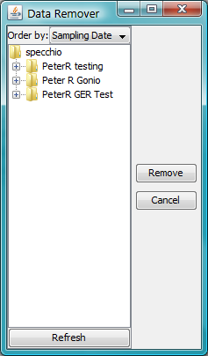

Figure : Data Remover dialog

* Use the spectral data browser to select the nodes or spectra that you wish to remove. Multiple spectra and nodes can be selected by using the Shift and Control keys. You can select any node except the specchio root node. Selecting a Campaign node is valid.
* Click the  Remove  button. All data that is below the selected node or nodes will be deleted. For example, if a Campaign is selected then all hierarchies and spectra belonging to this Campaign will be deleted. In addition, all metadata that has been entered for the deleted objects will be removed along with the objects.

Warning There is no further prompt to warn you. The data are deleted as soon as you click the  Remove  button. This action cannot be undone.

* Close the dialog box by clicking on  Cancel .

Removing data can take a long time. A progress bar shows which hierarchy is currently being removed.

## Campaign Export

%%% Review

The campaign export functionality is used to write all data of a campaign to an xml file while retaining the relational structure. These xml files can then be used to import the campaign into another SPECCHIO database instance.

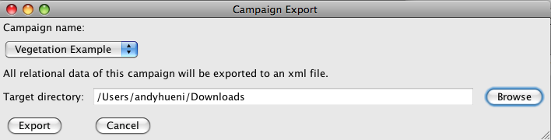

Figure 96: Campaign Export Dialog

The xml file structure contains all table entries that are required to reproduce the exported campaign in its relational structure. Entries are ordered by their inserting sequence, i.e. the campaign import will carry out the inserts in the order given by the file.

## Campaign Import

%%% Review

The Campaign import function is only available for users that have the rights equal to the SPECCHIO database administrator user (sdb\_admin). The import function requires an xml file created by the SPECCHIO campaign export function. The import will create an exact copy of the exported campaign and will insert new system table entries if required (e.g. new sensor definitions).

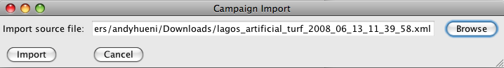

Figure 97: Campaign Import Dialog

The import function resolves all primary key – foreign key relations, making the imported campaign fit seamless into the existing data environment, i.e. no possible conflicts between the imported and already existing campaigns.

Note The export and Import database versions must be the same. Specchio does not check this.

Warning Issues of system table duplication may arise if the Institute or User Information tables are not identical in both Export and Import databases. %%% This should just be part of the instructions.

## Definition of new Sensors

New sensor can be defined by loading a sensor definition file.

Select Data Maintenance and Load sensor definition from the menu on Specchio’s Main Window. The following dialog is displayed.

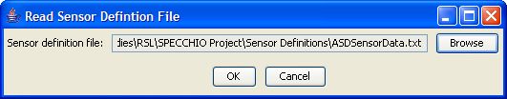

Figure 98: Read Sensor Definition File dialog

In this dialog, specify the sensor definition file and click  OK  to read the file and insert a new sensor into the database.

Sensor definition files are tab separated text files that can be edited in a text editor or in Excel (cf. ).

The file format is as follows:

Name Description Company Type no no of channels

<sensor name> <sensor descr> <company name> <type number> <no of channels>

Band Average Wavelength(nm) FWHM (nm)

<band number> <wavelength> <fwhm>

<band number> <wavelength> <fwhm>

<band number> <wavelength> <fwhm>

:

:

%%% There are extra tab characters in the above which will not show in a PDF or on paper. Are they required? Is this intended to be directly Cut and Paste from MS-Word as an example?

%%% The column headings don’t match in the above and below examples. Are they ignored, or used? What if they’re misspelt or wrong case?

The type number is a number given to a sensor, e.g. the ASD FSFR sensor has type number 4. The type number is usually part of spectral data files and the data loader can use it to automatically assign the correct sensor to a spectrum.

%%% Where is the list of Sensor type numbers defined? Or does the User assign the number they want? If so, what’s it used for? What’s it used for anyhow? Why do the Name and Type no effectively provide the same information?

The FWHM is currently not read into the database. %%% Does it need to be present? Can you have other unused columns?



Figure 99: Part of a sensor definition file being edited in Excel

## Instrumentation Administration

The instrumentation administration comprises metadata editing for instruments and reference panels. Any user can open the dialogs but only administrators will be able to commit any changes to the database.

Editing data is identical with the function of the Metadata editor for spectral data. Every change of a field activates the ‘Update’ button.

The dialog consists of two tabs: (a) Instrument Data and (b) Reference Data.

### Instrument Administration

The instrument data tab allows adding, editing and removing instruments and editing their metadata (Figure 100).

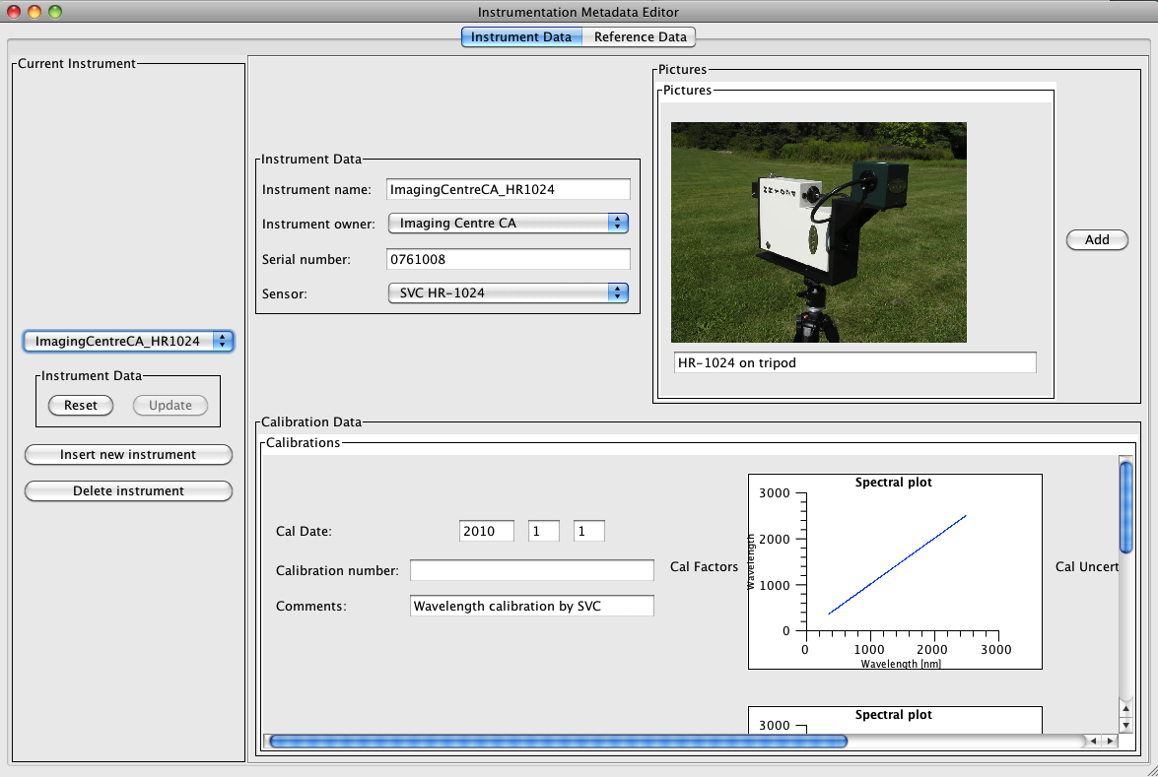

Figure 100: Instrument data tab of the instrumentation administration window

To edit or remove an instrument, select the instrument in the instrument list first.

Removing an instrument is achieved by clicking ‘Delete instrument’. A confirmation dialog will be displayed (Figure 101):

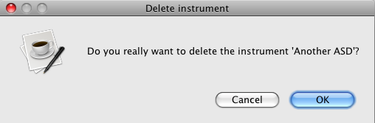

Figure 101: Instrument deletion confirmation dialog

An instrument cannot be deleted while still referenced by one or more spectra in the database. An according message will be shown if the delete action failed (Figure 102):

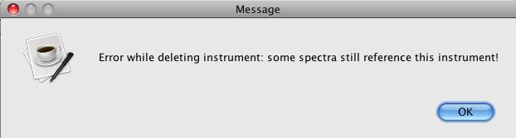

Figure 102: Instrument deletion error

The currently selected instrument will only be removed if no database constraints are violated.

To insert a new instrument, click ‘Insert new instrument’. A new record is created in the database and the instrument name is set to ‘dummy’ (Figure 103).

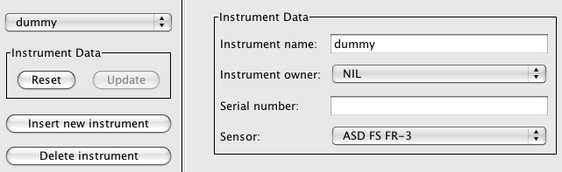

Figure 103: New 'dummy' instrument

The instrument can now be renamed and it’s metadata filled accordingly.

To add a new calibration to an instrument, click the menu button over the ‘Calibrations’ section of the Instrumentation Metadata Editor and choose ‘Add calibration’ or ‘Add calibration from file’ (Figure 104).

Selecting ‘Add calibration from file’ will bring up a file-choosing dialog. Two file types can be currently used to load calibration factors from: (a) HR-1024 spectral files (for loading the wavelengths calibration) and (b) TXT files as further detailed in the section on reference panels below (there is currently no real use in loading TXT files for instrument calibrations as only wavelengths are actively used in the system and these can currently only be loaded from HR-1024 spectral files).

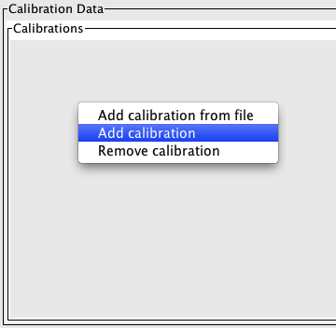

Figure 104: Adding calibrations

### Reference Panel Administration

The reference data tab allows adding, editing and removing reference panels and related metadata, in particular panel calibration data (Figure 105).

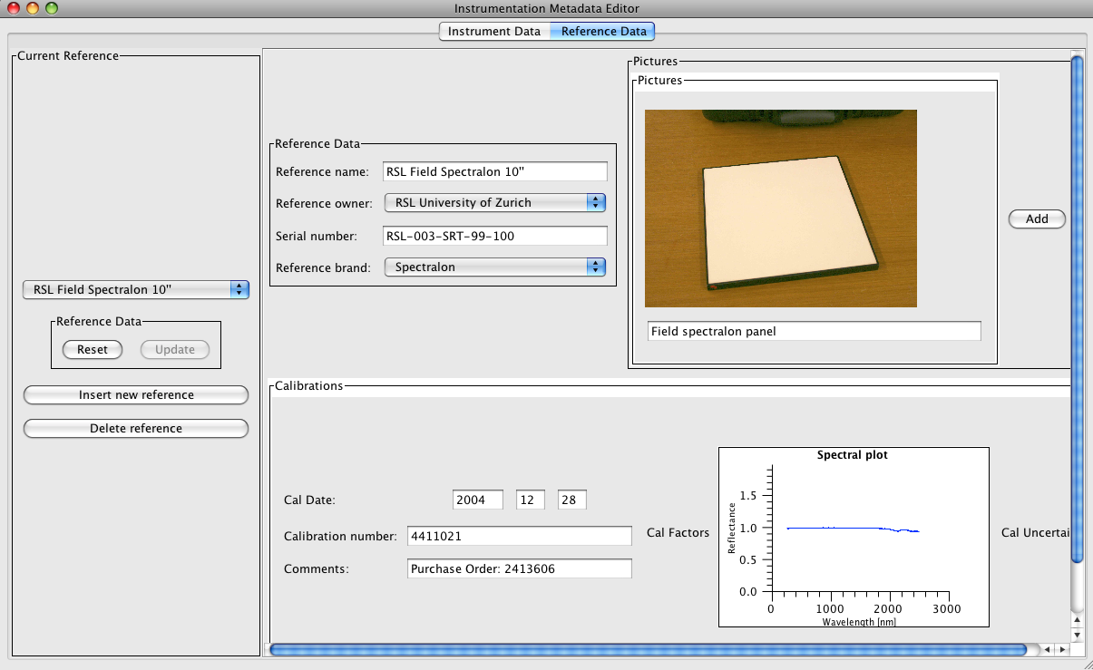

Figure 105: Reference data tab of the instrumentation administration window

To edit or remove a reference panel, select the reference in the reference list first.

Removing a reference is achieved by clicking ‘Delete reference. A confirmation dialog will be displayed

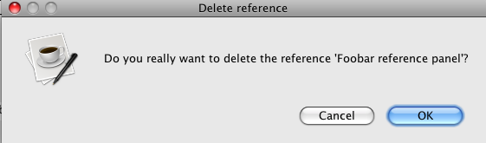

Figure 106: Reference deletion confirmation dialog

A reference panel cannot be deleted while still being referenced by one or more spectra in the database. An according message will be shown if the delete action failed (Figure 106). The currently selected reference will only be removed if no database constraints are violated.

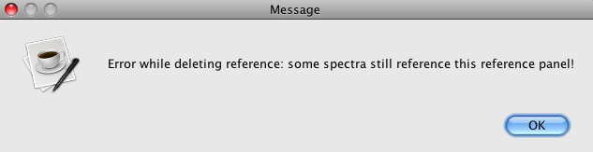

Figure 107: Panel deletion error

To insert a new reference, click ‘Insert new reference. A new record is created in the database and the reference name is set to ‘dummy’ (Figure 108).

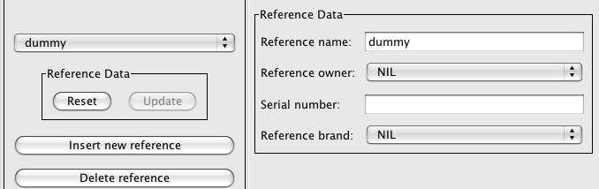

Figure 108: New ‘dummy’ reference

The reference can now be renamed and its metadata filled accordingly.

To add a new calibration to a reference, click the menu button over the ‘Calibrations’ section of the Instrumentation Metadata Editor and choose ‘Add calibration’ (Figure 109).

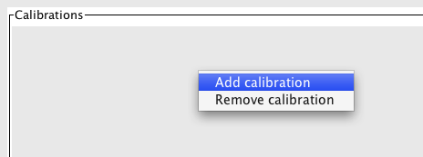

Figure 109: Popup menu for the reference calibrations

Use the file browser to select a calibration file (see below for a description of the file format) and click ‘Open’ (Figure 110).

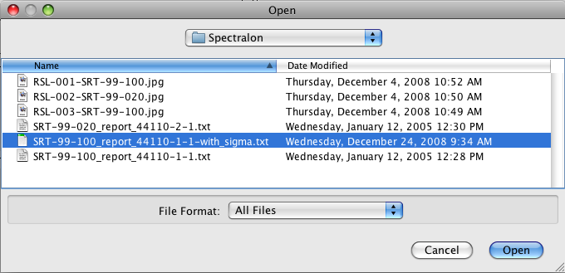

Figure 110: Calibration file selection dialog

A calibration file holds the calibration factors and uncertainty estimations for a reference panel in a tab separated value file:

wvl rho sigma

250 0.98 0.02

251 0.98 0.02

252 0.981 0.02

253 0.98 0.02

254 0.98 0.02

255 0.981 0.02

256 0.98 0.02

257 0.98 0.02

258 0.98 0.02

259 0.981 0.02

260 0.98 0.02

261 0.98 0.02

262 0.978 0.02

263 0.979 0.02

The wvl column holds the wavelength in nanometers, rho is the calibration factor linking the measured reference panel to the laboratory or national reference. I.e. in the above example, the panel is 98% reflective compared with an ideal panel. Sigma is the uncertainty estimate of rho, expressed as one standard deviation.

Note that before loading the calibration file, a sensor definition fitting the wavelengths of the calibration must be loaded to the database. E.g. in the case of Spectralon reference panels, the sensor definition is the Perkin-Elmer Lambda 19 sensor.

The calibration factors are used during the reference panel correction procedure as described in 9.4.2 and 9.4.3.

# Matlab Integration

The Matlab environment is a well-established tool in engineering, research and science. Matlab includes a Java Virtual Machine and thus allows the use of Java classes within Matlab code.

Starting from version 2.1.2, SPECCHIO includes new methods that allow the easy integration of SPECCHIO classes, giving easy access to the spectral data and metadata stored in SPECCHIO databases.

To use Matlab with Specchio, please refer to the Specchio MATLAB Guide **SPECCHIO\_MATLAB\_Guide.pdf**, which is included in the deliverables of the SPECCHIO package.

%%%% There is a menu for copying Matlab-ready query specs. It sort of replaces the SQL query method.

%%%% Java app acts as system layer. You import the Specchio .jar file into Matlab and then Matlab knows about Specchio entities. It needs further testing. Nick has a Matlab licence.

# Tutorial

The tutorial is comprised of four parts illustrating the functionality of SPECCHIO:

Part 1: Loading, Editing and Retrieving Data:  
The folder and directory structure of a sampling campaign, the creation of a new campaign, loading of data, editing of metadata and data retrieval is shown on a vegetation example. The data set contains ASD spectra of New Zealand native plants.

Part 2: Handling of GER Files:  
The automatic splitting of GER files into target and reference radiances upon loading is demonstrated using a RSL GER3700 dataset.

Part 3: Directional Data:  
The handling of directional data including sun angle and sensor geometry calculation and automated linking of target to reference spectra is demonstrated using RSL FIGOS goniometer data.

Part 4: Data Querying, Processing and Exploration

Each part contains several exercises that are listed in a logical order. In order to support the learning process every exercise lists the relevant sections in the User Guide.

All tutorial data are available for downloading on [www.specchio.ch](http://www.specchio.ch). %%% Is this true? Wouldn’t it be a UOW test database, as below?

The test data sets used for the specific tutorial parts are explicitly specified at the start of the respective section.

## SPECCHIO Online Test Database

%%% Will UOW set up a test database for Users to learn the system?

Relevant section: 5.3

An online test database is provided on db.specchio.ch. Please use this database for the tutorial exercise and all other tests you would like to carry out.

%%% What are the restrictions of such a database – e.g. does it support Publishing to ANDS? Is it cleaned out and reset on a regular basis so it remains usable? Who to contact if there’s a problem or you want it hosed out?

To change you database connection to the test database, select ‘Database‘->‘Connect to database’ from the main menu.

Connect to the test database by entering ‘specchio\_test’ in the database connection dialog (cf. ). Note that the user name and password you received when creating a SPECCHIO account are identical for both the productive and the test databases (specchio, resp. specchio\_test). %%% Really? Seems odd that the password would be the same? Why is this?

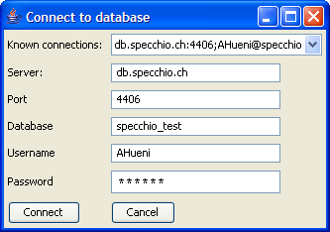

Figure 111: Connecting to the specchio\_test database

### Creating Campaigns on the Test Database

%%% What conventions are going to be used in the UOW database? Should they be documented here? Will they be the same as Andy’s database conventions?

In order to keep things organised, always include your name in the campaign name by using the following template: <your name>\_<campaign name>, e.g. Andy\_veg\_example. This will make it easier to find your campaigns in the Query Builder where you can see all campaigns of the other users as well (Note that the Query Browser includes a switch that will show only your own data).

### Downloading Test Data Sets

%%% Do we want Users to download from here?

The data sets used in this tutorial are available on the internet: <http://specchio.ch/tutorial_data.php>.

The following data sets are provided as ZIP archives:

* vegetation\_example.zip
* ger\_example.zip
* gonio\_example.zip

To download the ZIP files click on the links and select ‘Save to Disk’ in the web browser dialog (see Figure 112).

Unzip the ZIP files to some working directory on your machine, e.g. create a new folder called ‘SPECCHIO\_data’ and unzip all datasets into this directory.

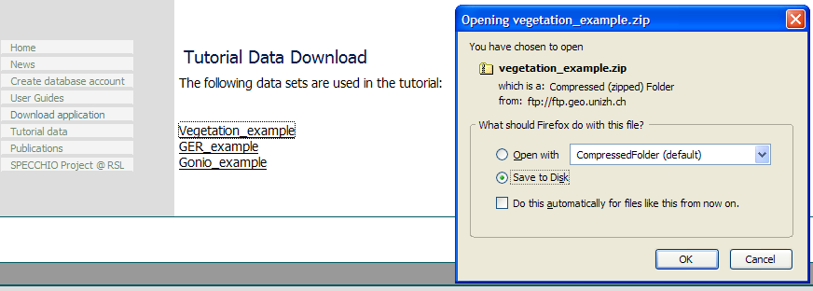

Figure 112: Tutorial data download page

## Part 1: Loading, Editing and Retrieving Data

Data set: Vegetation\_example

### Examine the Folder and File Structure

Relevant sections: 4.2, 4.3

Open a filing system window and browse the directory structure of the ‘Vegetation\_example’ folder.

It contains three species folders: Blackfern, Cabbage tree and Lemonwood. Open each of these species folders and examine the contents of the site directories contained in them. Blackfern has only one sample site while Lemonwood and Cabbage tree have three resp. two. Also browse inside the site directories to find the ASD binary files (cf. Figure 113).



Figure 113: Folder and file structure of the Vegetation\_example campaign

### Creating a new Campaign and Loading the Spectra

Relevant sections: 5.4, 6.2

Create a new campaign by selecting ‘Data Input ‘->‘Create new campaign’. In the new dialog, enter <your name>\_veg\_example as campaign name, e.g. ahueni\_veg\_example. Set the Main directory to the Vegetation example folder (cf. Figure 114).

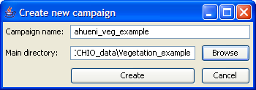

Figure 114: Creation of a new campaign for the vegetation example

Press the create button and a message box should pop up informing about the successful creation of the campaign (cf. Figure 115).

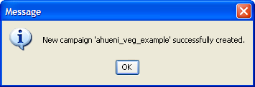

Figure 115: Message box informing on successful campaign creation

Once the campaign has been created load the spectral data of your campaign by selecting ‘Data Input’->’Load campaign data’ and selecting the campaign you just created (cf. Figure 116).

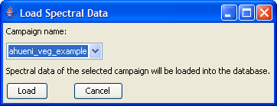

Figure 116: Loading spectral data into a campaign

A message box pops up when the campaign has been loaded (cf. Figure 117). A total of 64 spectral files should now have been loaded into the database.

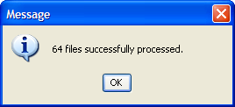

Figure 117: Message box showing the number of processed files during campaign loading

### Get to Know Your Data

Relevant section:

Your data are now ready to be visualised and exported. Open the Query Builder by selecting ‘Data Processing & Output’->’Build query’. In the Spectral Data Browser (the tree like display on the left side of the dialog) select your campaign (tick the box ‘Show only my data’ to restrict the displayed campaigns to your own) and explore the structure. Note that the database has stored the hierarchical structure of the campaign folder and displays it accordingly (cf. ). Also note that as you click around the tree (selecting folders or files) the SQL query and the number of resulting rows on the right side are updated simultaneously. You can also use Ctrl and Shift keys to do multiple selections.

Now select the first 6 spectra of the Blackfern, site1, (the number of resulting rows should be 6) and click on ‘Show report’. A new window will appear looking similar to . Note that a scrollable list containing the metadata is associated with every spectrum. Have a look at the metadata and note the data filled in automatically: filename, capture date, spatial position, measurement unit, sensor name, number of spectral channels, instrument name, owner and serial number.

The strong noise in the water bands is due to the generally high humidity found in New Zealand (maritime climate coupled with high yearly rainfall (up to 10 metres in Fjordland)).

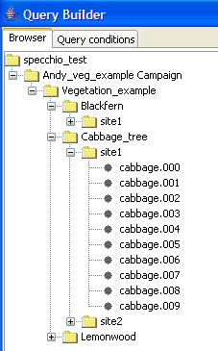

Figure 118: Vegetation example campaign shown in the Spectral Data Browser of the Query Builder

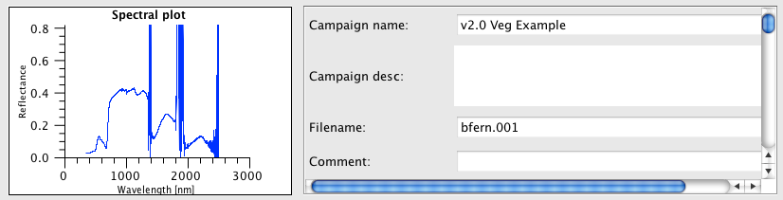

Figure 119: Part of the report on Blackfern spectra

### Exporting Data to CSV

Relevant sections: ,

Select File Export in the Query Builder (first select some data as described in ). Specify CSV as file format, an output directory (use the Browse button to select a directory) and a base filename and then press ‘OK’ (cf. ) (see also ).



Figure 120: File export dialog

A message box will appear once the export is finished.

Use your file system browser to have a look at the output file that has been written into the output directory you specified (cf. ). The file name is partly auto-generated and includes the following parts:

* blackfern: the base name you specified
* INR\_ASD: name of the instrument used to sample the data
* ASD FS FR-3: the sensor type

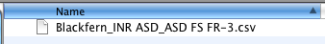

Figure 121: Exported CSV file

CSV files can be conveniently loaded into spreadsheet and statistics applications. Alternatively you can view them in a text editor.

CSV files can be split into header and body, where the header contains all metadata and the body consists of the channel and spectral information.

shows a spectral plot of the first six Blackfern spectra in Microsoft Excel. The first column contains the central wavelength of the bands in nanometres.

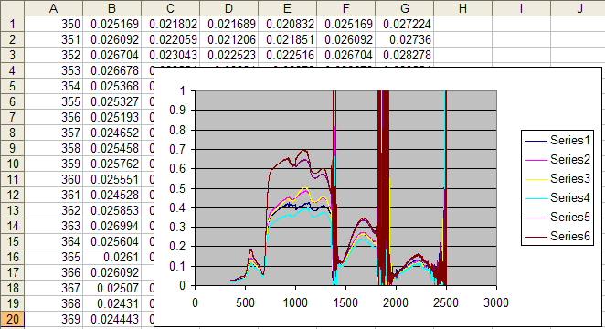

Figure 122: Example of a spectral (XY) plot in Microsoft Excel

### Exporting Data to ENVI Spectral Libraries

Relevant sections: ,

Note This exercise assumes that you have access to ENVI. If this is not the case you may skip it.

As a first step repeat the process of file exporting as described for CSV Files in 12.2.4 but change the file format to ENVI SLB.

To open SLB files in ENVI, start ENVI and select ‘Spectral’->’Spectral Libraries’->Spectral Library Viewer’. Specify an input file by selecting the .slb file (cf. Figure 123).

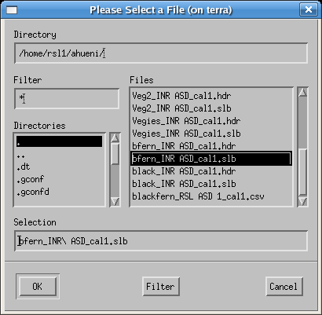

Figure 123: Selecting an slb file to load as spectral library

The spectra names can then be displayed in the Spectral Library viewer (cf. ) and plotted as Spectral Library Plots. Note that the maximum range of the Y axis must be set to 1 manually as otherwise only noise will be visible (cf. ).

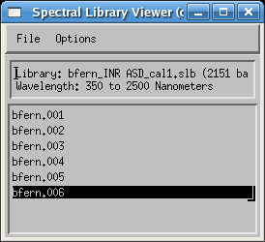

Figure 124: Spectra listed in the Spectral Library Viewer

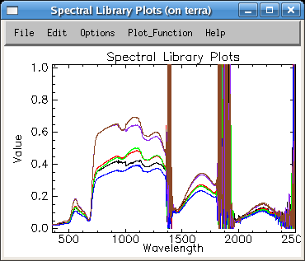

Figure 125: Blackfern spectra as Spectral Library Plots

### Editing Metadata

Relevant section:

Open the metadata editor by selecting ‘Data Input’->’Edit metadata’ from the main menu and select your campaign. Note that in the ‘Campaign Data’ tab your name is automatically listed as Investigator.

Enter some description into the description text field, e.g. ‘Just a test’. Note that as soon as you change some data in the metadata editor the relevant ‘Update’ button (in this case the button in the campaign data section) gets activated (cf. ).

Perform the update by clicking on the update button. This stores your changes in the database. The update is done when the ‘Update’ button reverts to being grey and inactive.

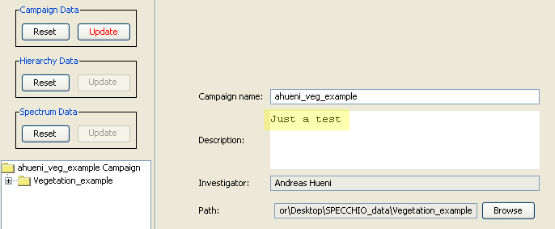

Figure 126: Editing the description of a campaign

Switch to the ‘Spectrum Data’ tab and select the ‘Blackfern’ folder in the Spectral Data Browser (cf. Figure 127).

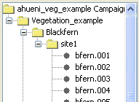

Figure 127: Selecting 'Blackfern' in the Spectral Data Browser of the Metadata Editor

By selecting multiple spectra (e.g. by selecting a folder or several single spectra) you automatically enter the so called ‘group update modus’. All data that you enter will apply to all the selected spectra. Note that some fields are not editable but greyed and inactive. These fields contain already individual spectrum metadata and are therefore disabled.

As all the spectra under the Blackfern hierarchy are of the same plant species and entering the plant names can be done for all spectra with a single operation. To enter a new name, click ‘Add’ in the ‘Names’ section. First type the common name ‘Blackfern’, then specify the type as ‘Common’ from the list (cf. ). In a similar manner enter the Latin name: ‘Cyathea medullaris’.

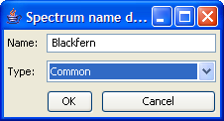

Figure 128: Entering a common name

The names now appear as shown in Figure 129. Note that the ‘Update’ button of the ‘Spectrum Data’ section has been activated. Perform now the update on the database by clicking the ‘Update’ button.

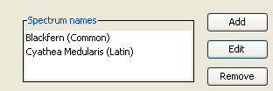

Figure 129: Spectrum names

All three species (Blackfern, Cabbage Tree and Lemonwood) are typical for New Zealand forests. They all share a common landcover type. To set the landcover for all spectra, first select the top folder called ‘Vegetation\_example’.

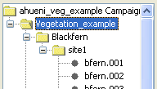

Figure 130: Selecting the top folder 'Vegetation\_example'

Now select the landcover type ‘Deciduous Forest’ in the CORINE landcover tree (cf. ). Press ‘Update’ to apply the selected landcover type to all spectra of this campaign.

You can now check the fact that indeed all spectra have this landcover type set by selecting single spectra in the Spectral Data Browser.

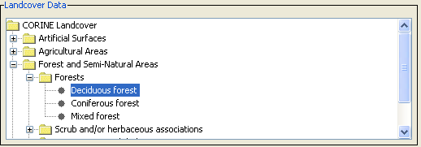

Figure 131: Specification of the landcover

Pictures taken at the sampling sites can be entered into the spectral database. Pictures for Blackfern and Lemonwood are provided in the vegetation\_example.zip file. You will find the pictures alongside with the Vegetation\_example folder in the directory where you un-zipping the data.

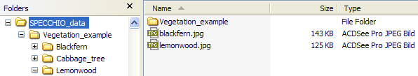

Figure 132: Location of the species pictures

To apply the Blackfern picture to all Blackfern spectra select the Blackfern hierarchy in the Spectral Data Browser. Click ‘Add’ in the Pictures section, browse to the Tutorial folder and select blackfern.jpg. To enter a caption, simply type it into the editable field below the picture (cf. Figure 133). Then update the database.

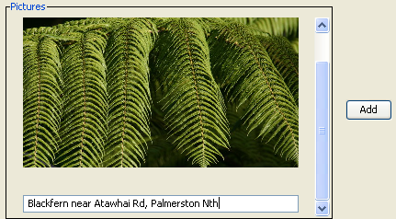

Figure 133: Example of a picture with a caption

In a similar manner insert the supplied lemonwood.jpg picture for all Lemonwood spectra.

Note that performing group updates not only speeds up the input process but also minimizes the amount of data stored in the database. All spectra in the selected group are referencing a single entry in the database, thus avoiding data redundancy.

A general problem of spectral data collections is the quality and trustability of the data. This is especially true if the data were collected by third parties and the sampling conditions are unknown. One way to improve the usability and shareability of spectral data is to include more metadata. SPECCHIO addresses this by the means of metadata quality levels (cf. **Error! Reference source not found.**).

In the Metadata Editor activate the checkboxes ‘Highlight mandatory fields’ and ‘Show quality compliance in tree’. Select the bfern.001 spectrum in the Spectral Data Browser and set the required quality level of this spectrum to B (cf. ).



Figure 134: Required quality level set to B

All required field should now be highlighted. Update the spectrum on the database. If the quality compliance is not shown in the tree, have it displayed properly by selecting your campaign explicitly again in the ‘Campaign Selection’ of the Metadata Editor (cf. Figure 27). All non-complying spectra plus the containing hierarchies are marked with an asterisk (cf. Figure 135).

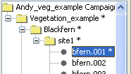

Figure 135: Non quality compliance indicated by asterisks

Fill in the missing metadata for the bfern.001 spectrum:

* Cloud cover: 1 okta or less, but not zero
* Beam geometry: Hemispherical-conical (CASE 8)
* Sampling Environment: Field
* Target Homogeneity: homogenous
* Sensor zenith: 0
* Sensor azimuth: 180 (this is equivalent to the principal plane opposite the sun)
* Sensor distance: 1
* Illumination zenith: 40
* Illumination azimuth: 0 (In the Southern hemisphere the sun stands in the North at midday)
* Target type: Add a new target type by clicking the ‘Add’ button, then specify the target type as ‘Tree’ and set it’s abundance = 100   
    
  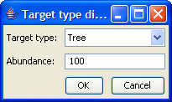

After updating the spectrum in the database, the non-compliance indicators in the spectral data browser should be removed.

## Part 2: GER Files

Data set: GER\_example

Relevant sections: , , , ,

The GER files are contained in the GER\_example folder. Explore the folder. You will notice that there are 10 files as created by the GER instrument. Create a new campaign to hold GER files (cf. ).

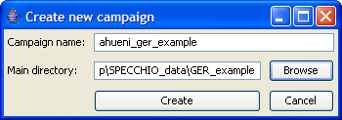

Figure 136: Creation of a GER example campaign

After creating the campaign load the spectral data into the database by selecting ‘Data Input’->’Load campaign data’ and selecting the campaign you just created (cf. Figure 137).

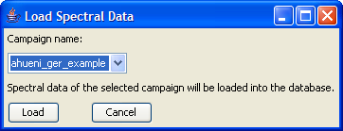

Figure 137: Loading spectral data into the GER campaign

Open the Query Builder. Open the tree of the GER campaign and study the contents. The files have been automatically split into target and reference spectra (cf. Figure 138). Remember that GER instruments write the sampled radiances of target and white reference into the same file. The names of the corresponding targets and references are identical, e.g. target GR083005.080 is associated with reference GR083005.080.

|  |  |
| --- | --- |
|  |  |

Figure 138: GER files split into target and reference spectra (left) and report showing target and reference spectra (right)

Targets and references are linked internally by a datalink on spectrum level (cf. 3.6). Open the Metadata Editor and display the spectrum data for one of the GER target spectra. Note that a link referring to the reference spectrum of the type Spectralon has been created (cf. Figure 139).

These datalinks are used during radiance to reflectance conversion.

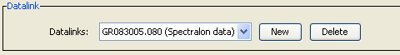

Figure 139: Automatically created link between target and reference spectra

## Part 3: Directional Data

Data set: Gonio\_example

Relevant sections: , ,

This exercise uses FIGOS goniometer data. FIGOS is used at RSL to acquire spectrodirectional measurements in 66 points arranged on a hemisphere. For more information please refer to Schopfer et al. (2007).

Goniometer data is provided in the Gonio\_example folder. It contains two subfolders: one holding the targets and one the references. The spectra of targets and references have been manually moved to these folders. This separation should be carried out before the data is loaded into SPECCHIO (alternatively all data can be loaded and the unwanted spectra removed using the Data Remover tool). It must also be noted that any surplus measurements must also be removed, i.e. the system expects 66 directional measurements maximum. SPECCHIO can however deal with gaps in the data as will be demonstrated hereafter.

Create a new campaign for goniometer data and load the campaign data.

If you explore the data in the Metadata Editor, you will find that the Measurement unit has been set to Radiance and the FOV to 3 degrees. Use a group update to set the Beam geometry of all spectra of this campaign to ‘Hemispherical-conical (CASE 8)’.

In the Metadata Editor select the special function ‘Link targets to references’ (cf. ). In the ‘Link Target to Reference’ dialog select the target and reference directories of the goniometer campaign as inputs (cf. ) and press ‘Link’. The datalinks have now been created.

In the Metadata Editor explore the datalink settings (cf. ). You should find that the targets triticaa.001 and triticaa.002 are referencing the triticaa.000 white reference spectrum. Targets triticaa.003 – triticaa.009 reference triticaa.006 and so on and so forth. The linking mechanism is based on the spectrum capture time and does not depend on the spectrum file name.

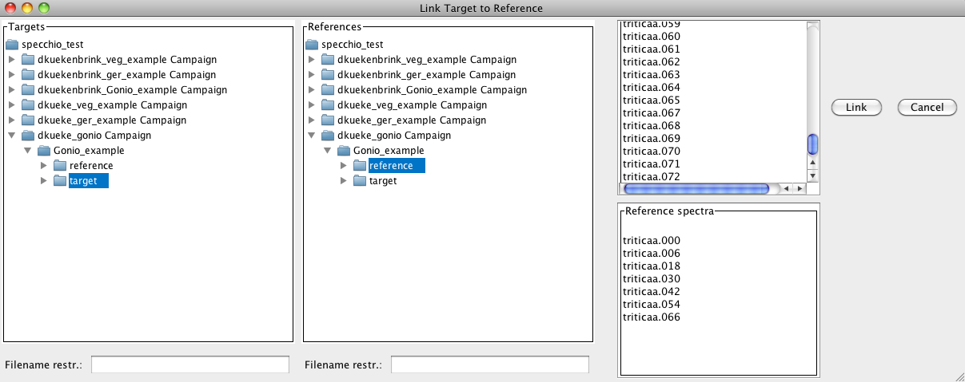

Figure 140: Specifying target and reference directories

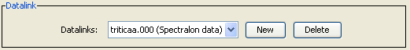

Figure 141: Example of an automatic created datalink

The illumination geometry (i.e. the sun zenith angle and azimuth) can be calculated automatically if the spatial position (latitude and longitude) and the capture time in UTC are known.

For the given dataset we assume that the time is local time and not UTC. This can be corrected by the special function ‘Correct local time to UTC’ (cf. ). In the time correction dialog select the Gonio\_example folder because the time shift should be applied to both target and reference spectra. The time difference to GMT is 2 hrs (East) as the sampling took place during summer in Switzerland, i.e. daylight saving applies (cf. ).

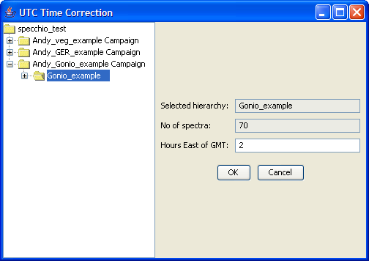

Figure 142: Applying a time shift to goniometer data

As a next step the coordinates of the sampling area must be defined. A position of N47° 22.400’ E08° 32.438’ is assumed. Positions must be entered as floating point degrees (GARMIN hddd.ddddd° format). This yields: N47.37333° E08.54063°.

In the Metadata Editor select the Gonio\_example hierarchy in the Spectral Data Browser. As the position applies to all spectra of the campaign a group update should be carried out. Now enter the latitude (47.37333) and longitude (-8.54063). Longitudes East of Greenwich are negative.

Having entered position and time (do not forget to press the ‘Update’ button), the calculation of the illumination geometry can be carried out by clicking the ‘Calc Sun Angles’ button (cf. ).

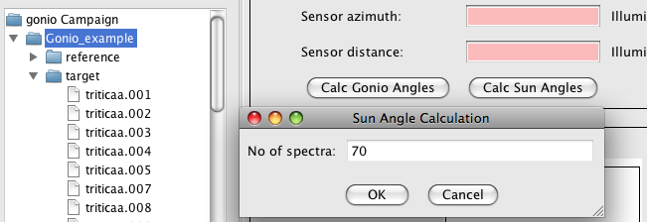

Figure 143: Sun angle calculation for goniometer data

Use the Spectral Browser of the Metadata Editor to check the sun angles that have been calculated. Every spectrum has been assigned slightly differing sun angles according to the individual capturing time.

The angles of the goniometer can be calculated for each spectrum using the ‘Calc Gonio Angles’ function (cf. ). Select the target hierarchy and click the ‘Calc Gonio Angles’ button. On the left side of the dialog the number of spectra in the selected hierarchy is displayed (63 spectra). There are three spectra missing from the normal total of 66. If you study the names of the target spectra it seems that the missing spectra numbers are: 55, 56 and 57. Specify the gaps as 55,56,57 and press ‘Insert gaps’. The total number of positions is shown in the field ‘Spectra + dummies’, i.e. 66 in this case. Press ‘Calculate’. The list above the ‘Calculate’ button now contains the positions (starting at zero), the calculated angles and the spectrum filenames. Scroll down till you find the inserted dummies called ‘gap dummy’ (cf. ).

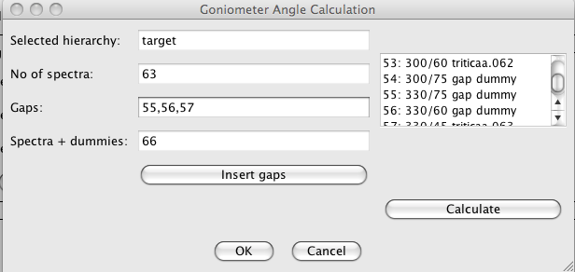

Figure 144: Inserted gaps and resulting angles

At this point you would have to refer to your field protocol in order to confirm that the gaps you specified did occur at the calculated angles. Let us assume that number 57 actually exists but number 60 is missing. Change the gap specification to: 55,56,60. Press ‘Insert gaps’ and ‘Calculate’ and check the list again. Once you are satisfied with the calculated angles press ‘Ok’ to store the angles in the database. Use the Metadata Editor to check that the angles have indeed been saved and are now correctly displayed.

E.g. for the spectrum triticaa.040 you should find a sensor zenith of 30° and azimuth = 270° (cf. Figure 145).

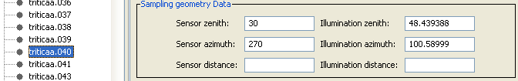

Figure 145: Calculated sensor zenith and azimuth angles

## Part 4: Data Querying, Processing and Exploration

### Converting Radiances to Reflectances

Data set: GER\_example

The GER example data set contains reference and target measurements that have been linked automatically during data load. Our goal is the conversion of target radiances to reflectances using the respective function of the Space Network Processor.

Open the Query Builder, browse to your GER example, select the targets hierarchy () and press the ‘Process’ button.

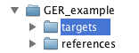

Figure 146: Selection of the target hierarchy of the GER example data set

A Space Network Processor window will open, containing a space holding the ten target spectra (Figure 147). The dimensionality of the space is 647, which is equal to the number of bands of the GER instrument.

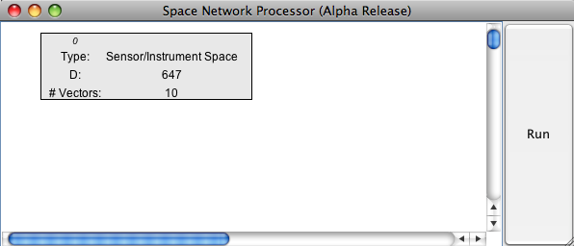

Figure 147: Space Network Processor window with space containing the target spectra

Add ‘Radiance to Reflectance Transformation’ as a new processing module to the processing plane by clicking the menu button over the processing plane and selecting the module.

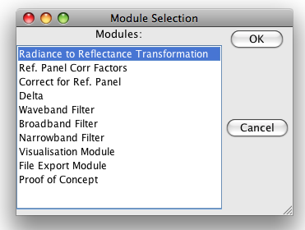

Figure 148: Selection of the ‘Radiance to Reflectance Transformation’ module

Connect the new module with the input space (space 0) by clicking the menu button over the module and selecting ‘Set Input Spaces’ in the module menu (Figure 149) and choosing space number 0 as input space (Figure 150).

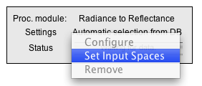

Figure 149: Module menu

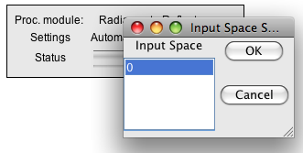

Figure 150: Input space selection for the ‘Radiance to Reflectance Transformation’ module

A new space is added to the processing plane automatically, containing to output of the ‘Radiance to Reflectance Transformation’ module (Figure 151).

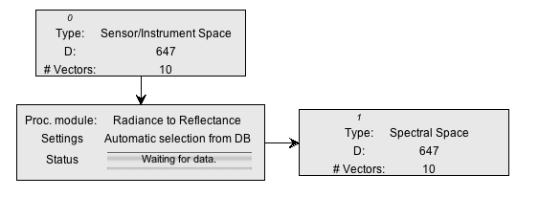

Figure 151: Input and output spaces of the ‘Radiance to Reflectance Transformation’ module

Now, we would like to see what this transformation is actually doing by plotting the input and output spectra.

Add two new modules of the type ‘Visualisation Module’ to the processing plane, configure them as ‘Spectral Line Plot’ and connect them with the input space (space 0) and the output space (space 1) respectively. Your Space Processing Network should now be similar to the one shown in .

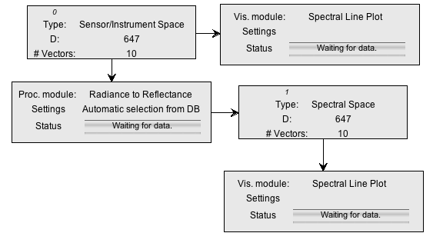

Figure 152: Space Processing Network for radiance to reflectance transformation and visualisation

Press the ‘Run’ button of the Space Network Processor and two spectral plots should appear (Figure 153).

|  |  |
| --- | --- |
|  |  |

Figure 153: Spectral plots of radiance and calculated reflectance

The calculated reflectances show the typical features of a vegetation spectrum (green peak, red edge, water absorption features). The high reflectance in the UV-Blue of the first few bands is an artefact of the instrument and indicates an unreliable calibration of the according channels.

### Data Queries

Data set: all campaigns loaded to the database.

If you worked through the whole tutorial a total of three new campaigns should now be loaded to the database. Note that you have access to campaigns other persons entered in the database. Queries on the database can thus return more rows than you might expect!

Open the Query Builder and switch to the ‘Query conditions’ tab.

In the wildcard field of the Campaign name type in your first or last name followed by the percentage sign, e.g. ‘hueni%’. Alternatively, select your name from the investigators list.

The number of resulting rows should be 154 (if all 3 tutorial data sets were loaded).

Select ‘Hemispherical-conical (CASE 8)’ as beam geometry The number of rows should drop to 70 and the autobuilt SQL statement looks similar to:

SELECT distinct count(\*) FROM spectrum, campaign WHERE campaign.user\_id = '6' AND spectrum.date >= 20050531105830 AND spectrum.date <= 20120224110223 AND spectrum.measurement\_type\_id = '2' AND spectrum.campaign\_id = campaign.campaign\_id

As a matter of fact, the spectra selected by this query all belong to the goniometer campaign that you created in this tutorial. The same result set is returned when the goniometer campaign is selected implicitly.

The result set can be further restricted by e.g. sampling geometry conditions. Narrow the search for spectra with zenith angles between 0º and 30º by entering a sensor zenith angle of 15 and a buffer size of 15 and sensor azimuth of 90 with buffer size 90 (cf. Figure 154).

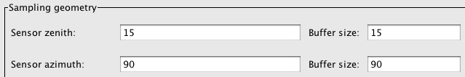

Figure 154: Specifying a sensor zenith/azimuth angles and buffer values

The resulting SQL statement should look like:

SELECT distinct count(\*) FROM spectrum, campaign, sampling\_geometry WHERE campaign.user\_id = '6' AND spectrum.date >= 20050531105830 AND spectrum.date <= 20120224110223 AND (sampling\_geometry.sensor\_zenith >= 0.0 AND sampling\_geometry.sensor\_zenith <= 30.0) AND (sampling\_geometry.sensor\_azimuth >= 0.0 AND sampling\_geometry.sensor\_azimuth <= 180.0) AND spectrum.measurement\_type\_id = '2' AND spectrum.campaign\_id = campaign.campaign\_id AND spectrum.sampling\_geometry\_id = sampling\_geometry.sampling\_geometry\_id

The number of resulting rows should be 17.

Press the ‘Process’ button in the Query Builder to load the selected data into the Space Network Processor. Add a new Visualisation Module, configure it as ‘Gonio Hemisphere Explorer’ and connect it with the input space (Figure 155).

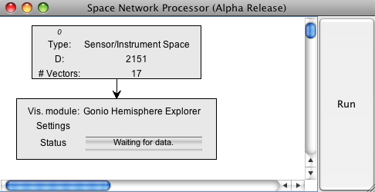

Figure 155: Gonio Hemisphere Explorer connected to the input space

Press the ‘Run’ button of the Space Network Processor. A Gonio Hemisphere Explorer window will open (Figure 156).

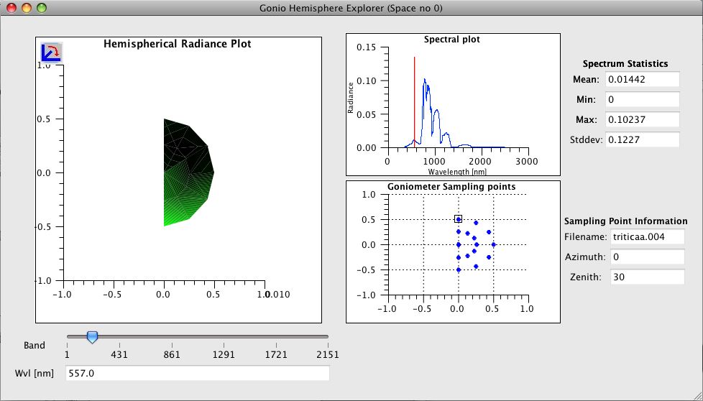

Figure 156: Gonio Hemisphere Explorer showing the data points selected in the Query Browser

Note that according to the selection in the Query Browser, only a limited number of points are displayed. The Gonio Hemisphere Explorer can handle any number of spectrodirectional data points and could thus be used on data stemming from different goniometer systems as well.

The data comprises spectrodirectional measurements of a wheat field (triticale). The hemispherical plot nicely illustrates the backward scattering of vegetation canopies (highest radiances are observed in the principal plane). The illumination source is at azimuth position 180° in the shown plot.

# Regular Expressions Tutorial

%%% This should be an appendix, but wait until the correct doc is available before considering that sort of change.

Regular expressions are widely used when string matching is required. They permit a rich array of sophisticated matching functionality.

A complete explanation of regular expressions is beyond the scope of this tutorial. Readers with a desire to see a complete list of all options should see the Java tutorial at <http://docs.oracle.com/javase/tutorial/essential/regex/index.html>.

The following is a quick summary of the most useful regular expression functions for Specchio Users.

|  |  |  |  |
| --- | --- | --- | --- |
| Simple string |  | A simple string containing no special characters will match that string, regardless of where within the target string it occurs. | mpl will match the string example at the fourth character. |
| Start of string | ^ | The character ^ will match the beginning of the string. | ^exa will match example, but ^xa will not. |
| End of string | $ | The character $ will match the end of the string. | le$ will match example, but pl$ will not. |
| Any character | . | The period character will match any character. | a.c will match abc, aac, adc, a7c and a-c but it will not match ac or abbc. |
| Repeated character | \* | Asterisk causes the matching to zero or more repetitions of the preceding character. | ab\*c will match ac, abc, abbc or abbbc, but will not match a7c or ahc. It will match aac at the second character and acc at the first character, because there are zero characters between the a and c in those strings. |
| Repeated characters | + | The plus sign causes the matching to one or more repetitions of the previous character. | ab+c will match abc, abbc or abbbc but will not match ac. |
| Alternate characters | [ ] | Strings enclosed within square brackets will match any one of the characters within the brackets. | a[123]b will match a1b, a2b or a3b only. It will not match ab or any other substring. |
| Character ranges | [-] | Use – between [] to match one of range of characters. | [0-9] matches any digit.  [a-z] matches any letter.  [a-z0-9] matches any digit or letter. |
| Escape character | \ | In order to match a special character, precede it with the backslash character.  Special characters are [\^$.|?\*+(){}  Putting \ before other characters often has a special meaning, so should be avoided. | \\ will match \  \. will match .  \\* will match \*  \[ will match [ |
| Combinations |  | Any of the above search methods can be combined. | ^.c will match any string with c as its second character.  ^abc$ will match the string abc only. abcd or aabc will not be matched.  1[abcd]+2 will match any combination of the characters a, b, c or d which occurs between the digits 1 and 2.  [\[\]] will match either [ or ].  \.+ will match any run of periods.  [0-9]+ will match any integer number.  [0-9]+\.[0-9]\* will match any number with a decimal point. |

# References – OLD %%%

%%% This chapter can be replaced by the auto-generated one which follows, after we have determined that the list is correct.

## References from Introduction:

[6].

[7].

[8].

[9].

[4].

[10].

[11].

[2].

[12].

[5].

[13].

[14].

## References from End Note field at end of document.

[14].

[4].

[12].

%%% I’m not using this one any more - ISO/IEC (1996). Information technology -- Syntactic metalanguage -- Extended BNF (14977). Geneva, Switzerland, ISO/IEC Copyright Office.

[3].

[15]

[16].

[17].

[1].

%%% This one is not used anymore - University of Washington (undated). "Total Cloud Amounts." from <http://www.atmos.washington.edu/gcg/MG/tepps/SPOON/photoen/cover.html>.

%%% This one is not used anymore - Wirth, N. (1977). "What can we do about the unnecessary diversity of notation for syntactic definitions?" Communications of the ACM **20**(11): 822-823.

# References

|  |  |
| --- | --- |
| [1] | Astronomical Applications Department of the U.S. Naval Observatory, “Universal Time,” 2003. [Online]. Available: http://aa.usno.navy.mil/faq/docs/UT.php. [Accessed 1 May 2013]. |
| [2] | A. Hüni and M. Kneubühler, “SPECCHIO: A System for Storing and Sharing Spectroradiometer Data,” December 2007. [Online]. Available: http://spie.org/x18220.xml. [Accessed 2007]. |
| [3] | D. Landgrebe, “On Information Extraction Principles for Hyperspectral Data,” Purdue University, West Lafayette, IN, 1997. |
| [4] | A. Hueni, M. Kneubuehler, J. Nieke and K. Itten, “Processing Extension for the Spectral Database SPECCHIO,” in *Proceedings EARSeL SIG IS*, Tel Aviv, Israel, 2009. |
| [5] | A. Hüni, J. Nieke, J. Schopfer, M. Kneubühler and K. Itten, “2nd Generation of RSL's Spectrum Database "SPECCHIO",” in *ISMPSRS*, Davos, Switzerland, 2007. |
| [6] | A. Hueni, M. Kneubuehler and M. Schaepman, “International Geoscience and Remote Sensing Symposium,” Hawaii, USA, 2010. |
| [7] | A. Hueni, T. Malthus, M. Kneubuehler and M. Schaepman, “Data Exchange Between Distributed Spectral Databases,” *Computers & Geosciences 37,* pp. 861-873, 2011. |
| [8] | A. Hueni and M. Kneubuehler, “SPECCHIO: A Free Spectral Data Management and Processing System,” in *SPIE Optics and Photonics*, San Diego, CA, 2009. |
| [9] | A. Hueni, S. Rey, D. Schläpfer, J. Schopfer and M. Kneubuehler, “Visualisation, Processing and Storage of Spectrodirectional Data Based on the Spectral Database SPECCHIO,” in *IGARSS 09*, Cape Town, South Africa, 2009. |
| [10] | A. Hueni, J. Nieke, J. Schopfer, M. Kneubühler and K. Itten, “The Spectral Database SPECCHIO for Improved Long Term Ssability and Data Sharing,” *Computers & Geosciences 35(3),* pp. 557-565, 2009. |
| [11] | A. Hueni, J. Schopfer, D. Schläpfer, M. Kneubuehler and J. Nieke, “Pre-processing of Dual-view FIGOS data: Towards Operational BRDF Retrieval,” in *Proceedings ISPRS*, Beijing, China, 2008. |
| [12] | A. Hüni, J. Nieke, J. Schopfer, M. Kneubühler and K. Itten, “Metadata of Spectral Data Collections,” in *5th EARSeL Workshop on Imaging Spectroscopy*, Bruges, Belgium, 2007. |
| [13] | A. Hueni and M. Tuohy, “Spectroradiometer Data Structuring, Pre-Processing and Analysis - An IT Based Approach,” *Journal of Spatial Science 51(2),* pp. 93-102, 2006. |
| [14] | A. Hueni, “Field Spectroradiometer Data: Acquisition, Organisation, Processing and Analysis on the Example of New Zealand Native Plants,” Institute of Natural Resources, Palmerston North, Massey University, 2006. |
| [15] | G. Schaepman-Strub, M. Schaepman and e. al., “Reflectance Quantities in Optical Remote Sensing - Definitions and Case Studies,” *Remote Sensing of Environment 103,* pp. 27-42, 2006. |
| [16] | J. Schopfer, “Spectrodirectional Ground-based Remote Sensing Using Dual-view Goniometry,” Remote Sensing Laboratories, Zurich, 2008. |
| [17] | J. Schopfer, S. Dangel and e. al., “Dual Field-of-View Goniometer System FIGOS,” in *10th Intl. Symposium on Physical Measurements and Spectral Signatures in Remote Sensing*, Davos, Switzerland, 2007. |

Document History

|  |  |  |  |
| --- | --- | --- | --- |
| **Version** | **Date** | **Author** | **Remark** |
| 0.1 | 15.12.2006 | A. Hueni | First valid version |
| 0.2 | 13.02.2007 | A. Hueni | - Instructions for entering pathnames under UNIX  - Updated installation description  - Bug fix update  - Tutorial |
| 1.0c | 14.02.2007 | A. Hueni | - Bug fixes and added features  - Version number of this document is now synchronized with the software version number. |
| 1.0d | 21.02.2007 | A. Hueni | - Minor software changes  - Some changes due to input from the first tutorial session |
| 1.0f | 29.05.2007 | A. Hueni | Added features:  - txt file reader  - CORINE landcover class displayed as tree in Metadata editor |
| 1.1 | 18.10.2007 | A. Hueni | Updates due to:  - adding multi-user capabilities to the data model and application.  - pre-configuration of database connection details via the db\_config.txt file  - Admin functions not visible for normal users  - Bug fixes |
| 1.1a | 03.11.2007 | A. Hueni | - Software updates and bug fixes  - Description of plot control  - other minor changes |
| 1.1b | 06.11.2007 | A. Hueni | - Change of the application bundle to flat file structure in order to prevent installation problems. Reflection of that change in the documentation. |
| 1.1c | 31.01.2008 | A. Hueni | - Added spectral plot to metadata editor  - Added campaign export functionality  - Time format option in the export dialog |
|  |  |  | - Bugfix: Position.Location field in Metadata editor now accepts alphanumeric input. |
| 1.2 | 29.05.2008 | A. Hueni | Major rework of the Metadata Editor:   * Super-fast group updates * Shared data highlighting * Shared data update reimplementation * Shared data awareness for gonio and sun angle calculations * Direct selection of gonio and sun angle calculations from the ‘sampling geometry field’ |
| 1.3 | 15.06.2008 | A. Hueni | Added campaign import function. Some bugfixes. |
| 1.3a | 25.07.2008 | A. Hueni | SPECCHIO would stall during data export due to the jgraph extension not being found. The application has been recompiled to include the jgraph extension in the needed extension list and jgraph is now bundled with the SPECCHIO application. |
| 1.3c | 26.09.2008 | A. Hueni | (a) A switch in the Query Browser that lets you restrict the data to your own data only,  (b) The Data Browser in the Metadata Editor is now contained in a scroll pane and thus also displays correctly on small screens. |
| 2.0 | 12.03.2009 | A. Hueni | Major update:   * Database schema update to include reference panel handling including correction factors and uncertainty * Processing extension * Instrument and reference panel handling tools * Updated export/import functionality |
| 2.0a | 26.03.2009 | A. Hueni | ENVI spectral library loading problem has been addressed. |
| 2.0c | 07.07.2009 | A. Hueni | Numeric fields in the Metadata Editor now accept copy&paste operations. Support for new DB fields for instrument settings. |
| 2.1 | 02.09.2010 | A. Hueni | - Added instrument settings support  - Added associated measurements support  - Names and Target Type dialogues have combobox values now updated when editing existing data.  - Copy&paste operations now also work under Windows.  - Config file reading routine more robust (multiple CR/LF possible and not causing a crash)  - Time selection for file output now works from the space network processor as well.  - Solved memory problem when loading > 3000 spectra plus further memory leaks.  - Bug fix for picture loading in instrumentation admin  - Added support for the SVC-HR1024 instrument  - Added calibration definition for instruments  - Added preliminary support for Apogee instrument |
| 2.1c |  | A. Hueni | - Added button for direct spectral plot from Query Browser  - Selection of space splitting approach in Query Browser  - Added filename wildcard field in Query Browser  - Progress info and multithreading for Data Remover  - Added handling for SVC HR-1024 instruments measuring in radiance mode |
| 2.1.1 |  | A. Hueni | - Bugfix for space splitting in Query Browser  - Bugfix for campaign restriction in Query Browser  - Preliminary support for SpectraSuite Data Files  - Increased number of decimals in CSV file output |
| 2.1.2 | 28.03.2011 | A. Hueni | Matlab integration updates |
| 2.2.0 | 02.05.2012 | A. Hueni  D. Kuekenbrink | Implementation of reading routine for FGI HDF-files  New database table to hold generic metadata  Update on automatic scaling of spectral plots  Update on target to reference linking: dialog remains open, allowing fast linking in the same hierarchy structure. Restrictions on filename are possible to select targets and references easier under mixed storage conditions.  Spectral data browser loading speedup  Metadata Editor: added filename restriction to allow better editing of metadata, e.g. under mixed storage conditions of references and targets.  Update of Data Remover: now allows the removal of several selected items at once.  Data Loader for new ASD binary file format  Date and time selection via GUI in Metadata Editor  Definition of beam geometries  Update of Query Builder, including start and end time specification and generic metadata restrictions |
| 2.2.1 |  | A. Hueni  D. Kuekenbrink | Upgrade of direct irradiance calculation function for MFR-7  EAV editing: bugfix  Splitting query building and hierarchy browsing into two GUIs to speed up the GUI loading.  Greatly improved space building efficiency and hence overall processing speed gain in the space network processor.  Enhanced API for efficient sampling geometry metadata extraction for a spectral selection.  Data loading now supports mixed directories (spectral files are loaded when mixed with sub-directories).  UniSpec file loaders (Dual and single beam instruments)  SPECPR file data loader |